Assessment Coversheet and Feedback Form | Arts, Design & Media

Complete the details marked in the coloured text and leave everything else blank. Where appropriate, copy and paste your submission after the first pages as indicated. You are reminded of the University regulations on cheating. Except where the assessment is group-based, the final piece of work which is submitted must be your own work. Close similarity between submissions is likely to lead to an investigation for cheating. You must submit a file in an MSWord or equivalent format as tutors will use MSWord to provide feedback including, where appropriate, annotations in the text.
Student Name | Edward Jonathan Turpie | Reasonable Adjustments
Student Number | 17126572 | The Faculty has notified me that I am eligible for a Reasonable Adjustment (including additional time) in relation to the marking of this assessment.  Yes/No (delete as appropriate)  Please note that action may be taken under the University’s Student Disciplinary Procedure against any student making a false claim for Reasonable Adjustments.
Course and Year | Postgraduate Certificate in Research Practice – SEPT 2017
Module Code
Module Title | Postgraduate Certificate in Research Practice
Assessment Title | Extended Research Proposal and Developing as a Researcher
Module Tutor | Oliver Carter, Kirsten Forkert, Chris Hill & Jacqueline Taylor

First Marker Name: |  | Date:
Feedback: General comments on the quality of the work, its successes and where it could be improved
 |  |  | Provisional Uncapped Mark Marks will be capped if this was a late submission or resit assessment and may be moderated up or down by the examination board.
 |  |  | %
Feed Forward: How to apply the feedback to future submissions

Quality and use of Standard English and Academic Conventions
 | Spelling Errors |  | Style is Colloquial |  | Standard is a Cause for Concern
 | Grammatical Errors |  | Inappropriate Structure | If the box above has been ticked you should arrange a consultation with a member of staff from the Centre for Academic Success via Success@bcu.ac.uk
 | Punctuation Errors |  | Inadequate Referencing
Second Marker: To ensure your mark is fair, a cross section of work is marked by another member of staff.
Second Marker Name: |  | Date:

Postgraduate Certificate in Research Practice - Marking Criteria

Please refer to the full marking criteria on the next page and provide a provisional mark for each element of the assignment.
The overall mark can be calculated using the PGCert marking calculator.

 | 0 – 39%  Fail | 40 – 49%  Marginal Fail | 50 – 59%  Pass | 60 – 69%  Strong Pass | 70 – 79%  Very Strong Pass | 80 – 100%  Exceptionally Strong Pass
ELEMENT 1  MARK | 1. Communicate the theoretical, methodological and practical aspects of the research and their impact
 | 2. Situate the project in its relevant field(s) and articulate the potential contribution/s their work will make to the existing body of knowledge
 | 3. Formulate clear and relevant research questions and methods and justify the development of an appropriate plan to realise the project
ELEMENT 2  MARK | 4. Critically reflect on your progress as a doctoral researcher and formulate a plan for your future professional development

Postgraduate Certificate in Research Practice: Assessment Criteria
Assessment criteria | 0 – 39%  Fail | 40 – 49%  Marginal Fail | 50-59%  Pass | 60-69%  Strong pass | 70% - 79%  Very strong pass | 80 – 100%  Exceptionally Strong Pass
Assessment criteria 1:  Communicate the theoretical, methodological and practical aspects of the research and their impact | There is little or no evidence of the theoretical grounding of the research and the work does not evidence independent thinking or the potential contributions to knowledge. Poor or inadequate communication of a research methodology and the practical aspects of carrying out the research. | There is some evidence of the theoretical grounding of the research, however the work does not sufficiently demonstrate the capacity to develop ideas and to make a contribution to the subject. Some evidence of an appropriate research methodology and the practical aspects of the research, however more detail is required. There is little or no evidence of awareness of the impact of the research. | The research is underpinned by some theoretical grounding and demonstrates the capacity to develop ideas and to make a contribution to the subject. There is evidence of an appropriate research methodology and a developing awareness of the practical aspects of the research. There is evidence of some awareness of the impact of the research. | The research is underpinned by a good theoretical grounding and demonstrates the capacity to independently develop ideas and make a contribution to the subject. There is evidence of an appropriate and refined research methodology and a good awareness of the practical aspects of the research. There is evidence of a good awareness of the impact of the research. | The research is underpinned by a solid theoretical grounding and demonstrates the capacity to critically and independently develop ideas and make a contribution to the subject. There is evidence of a well-considered and appropriate methodology and a very good awareness of the practical aspects of the research. There is evidence of a very good awareness of the impact of the research. | The research is underpinned by a robust theoretical grounding and demonstrates a high level of independent critical thinking, reflection and a contribution to the subject. There is evidence of a well-considered, developed and appropriate methodology and an excellent awareness of the practical aspects of the research. There is evidence of an excellent awareness of the impact of the research.
Assessment criteria 2:  Situate the project in its relevant field(s) and articulate the potential contribution/s their work will make to the existing body of knowledge | There is little or no evidence of the research project being positioned in relevant field(s). The work lacks structure and organisation, and does not adequately articulate how the research is situated in relation to or contributes to existing bodies of knowledge. Supporting material is poorly integrated, used inappropriately or missing where required. Referencing is poor, with many omissions and inconsistencies. | There is some evidence that the research project is positioned in the relevant field(s), however this is not clear or explicit. The work has some structure and there is evidence of some organisation, however it does not clearly or coherently articulate how the research is situated in relation to or contributes to existing bodies of knowledge. Supporting material is adequate but requires greater contextualisation. Referencing is incomplete, with frequent errors and inconsistencies. | There is evidence that the research project is positioned in relevant field(s) of research practice and this position is basically explored. The work is adequately structured and organised, and competently articulates how the research is situated in relation to and contributes to existing bodies of knowledge through an emerging narrative or argument. Supporting material demonstrates some contextualisation and critical thinking. Competently referenced, but with some omissions or inconsistencies. | There is evidence that the research project is clearly positioned in relevant field(s) of research practice and this position is explored in some depth. The work is well-structured and organised and articulates well how the research is situated in relation to and contributes to existing bodies of knowledge through a persuasive narrative or argument. Supporting material demonstrates contextualisation and critical thinking. Referencing is accurate and demonstrates engagements with sources in the field(s) of study. | There is evidence that the research project is clearly and well-positioned in relevant field(s) of research practice and the position is explored critically and in depth. The work is very well-structured and organised and articulates very well how the research is situated in relation to and contributes to existing bodies of knowledge through a solid narrative or argument. Supporting material clearly demonstrates contextualisation and critical thinking. Referencing is accurate and demonstrates engagement with a range of sources. | There is evidence that the research project is effectively and clearly positioned in relevant field(s) of research practice and the position is explored critically and in depth. The work is extremely well-structured and organised and effectively articulates how the research is situated in relation to and contributes to existing bodies of knowledge through a carefully formulated narrative or argument. Supporting material explicitly and clearly demonstrates contextualisation and critical thinking at the highest level. Referencing is accurate and demonstrates engagements with a wide range of sources.
Assessment criteria 3:  Formulate clear and relevant research questions and methods and justify the development of an appropriate plan to realise the project | The work does not contain a formulated or coherent research question or problem. There is little or no evidence of links between research questions and method and no attempt. There is no research plan to justify the realisation of the project. | There is some detail of the research question or problem, however they are unclear or incoherent and require further refinement. There is limited evidence of the relationship between research questions and method, however more detail and/or understanding of methods are needed that demonstrate how the work will be achieved. The work contains a limited research plan that does not sufficiently justify how the project will be realised. | There is a basically formulated research question or problem, which sufficiently frames the wider research project. There is some evidence of the relationship between research questions and method. The work demonstrates a competent understanding of potential methods that support how the work will be achieved in some detail. The work contains a competent plan that adequately details and justifies how the project will be realised. | There is a well- formulated and developed research question or problem that effectively frames the wider research project. There is a good grasp of the relationship between research questions and method. The work demonstrates a good understanding of methods that clearly supports how the work will be achieved in detail. The work contains a considered plan that clearly details and justifies how the project will be realised with an awareness of any potential issues that might arise. | There is a well-formulated and developed research question or problem that clearly and effectively frames the wider research project. There is a very good grasp of the relationship between research questions and method. The work demonstrates a very good understanding of methodological choices appropriate to the research project that clearly and critically supports how the work will be achieved. The work contains a detailed and well-considered research plan that solidly justifies how the project will be realised, with some critical awareness of any potential issues that might arise. | There is an extremely developed research question or problem that clearly articulates the basis and scope of the research and effectively frames the wider research project. There is a sophisticated grasp of the relationship between research questions and method. The work demonstrates an excellent understanding of methodological choices appropriate to the research project that clearly and critically supports how the work will be achieved. The work contains a detailed, well-considered and developed research plan that robustly justifies how the project will be realised, with critical awareness of any potential issues that might arise.
Assessment criteria 4:  Critically reflect on your progress as a doctoral researcher and formulate a plan for your future professional development | Little to no evidence of reflection on professional development as a doctoral researcher, as well as little evidence of a plan for future professional development. The approach to career development is passive and there is little to no attempt to take ownership. Evidence of research practice demonstrates no critical awareness of the requirements of doctoral work. | Limited evidence of reflection on professional development as a doctoral researcher. There is some attempt to consider future professional development, but this is not formulated into a coherent plan. The approach to career development is largely passive, with limited attempts to take ownership. Evidence of research practice demonstrates little critical awareness of the requirements of doctoral work. | Evidence of some reflection on professional development as a doctoral researcher. There is a basic plan to consider future professional development, but it lacks detail, coherence and initiative. There is some evidence of taking ownership of career development. Evidence of research practice demonstrates some critical awareness of the requirements of doctoral work. | Evidence of good reflection on professional development as a doctoral researcher. There is a considered plan for professional development that demonstrates some coherence, thoughtfulness and initiative. There is some evidence of taking ownership of career development. Evidence of research practice demonstrates a good critical awareness of the requirements of doctoral work. | Evidence of very good reflection on professional development as a doctoral researcher. There is a well-considered and thought out plan for future professional development that coherently demonstrates ownership of career development. There is evidence of the student taking steps to integrate into a wider community of research practice. Evidence of research practice demonstrates a very good critical awareness of the requirements of doctoral work. | Evidence of excellent reflection on professional development as a doctoral researcher. There is a detailed, well-considered and developed plan for future professional development that coherently and clearly demonstrates an understanding of the challenges that the student will face and how to address them. There is much evidence of the student taking ownership of career development and identifying as an independent researcher within a wider community of research practice. Evidence of research practice demonstrates excellent critical awareness of the requirements of doctoral work.

Research title:
The Drawn Portrait in Contemporary Printmaking: A journey between analogue and digital Smart-phone digital photography, analogue drawing and printmaking and how it changes the image.
Situating the investigation - This research explores the potential of digital photography within the context of the drawn portrait as manifest through contemporary printmaking methodologies. Furthermore, it seeks to question how methodological choices affect the meaning embedded within the resultant image. The research will be situated in the context of fine art printmaking from its artisanal roots to 21st Century digital applications and seeks to answer three main questions. How can artists use smart phone photography to serve as a basis for drawn portraits and prints? What affect does smart phone photography have on the process of drawn portraiture and printmaking? Does the process from a smart phone photograph to a drawn portrait or print alter the meaning of the image?
The research will offer insights into the materiality of drawing and printmaking through the use of new creative and technological approaches to drawn and printed image reproduction. It will test boundaries of current digital photography, drawing, print practice and associated material approaches in new ways that fuse the historic, new, or appropriated. It will offer artists and printmakers advances in silkscreen methodologies that are akin to drawn qualities yet with the mechanically reproductive capabilities of multiplication. Finally it will offer technical information on contemporary fine art silk-screen and digital printmaking tools, processes and how they can be applied in the visual arts.

Introduction

I am in transition from a creative industrial career to one of doctoral research study; there is much to learn. That said I am hugely inspired by the challenge with its new lessons, structures and rewards ahead.

The informative and positively challenging supervision input from Director of Studies, Dr Catherine Baker and Dr Lawrence Green has ensured I investigate the premises of my established practice, approach to art, academe and scholarly writing. I have learned how to be vulnerable. Rather than conceive, draw and print in secure styles of depiction and representation. I have learned the value of challenging my habit formed norms to enable new (to me) methods to be developed within the context of contemporary portraiture. This is positive and makes for constant creative review of art and the act of decision-making within drawing practice. Pursuing my research from this vulnerable position is an indication of how I shall continue – by being open to new thinking, research methods, artistic approaches and learning outcomes.

I have begun my theoretical research with a wide-ranging exploration of knowledge in my research domains. Much is new (to me), although some of my thinking has been percolating in my brain over the last 30 years or so, and it is now time to substantiate generalities of thought with deeper research thinking, understanding and knowledge.

My literature review has been broken down into the main question of study: Contemporary Portraiture, and the 3 practice based domains of ‘digital Photography; Drawing; Print Making’. These strands with their own paths, structures and histories will be collated to form an integrated knowledge base to provide the foundation for the overall research plan.

I shall continue this exploration of practice and theoretical research until I have satisfied myself, and peers, that the research has reached an academically robust stage. At that point I will bring together the three stands under the overall question and address, through my research activities and acquired knowledge, what Contemporary Portraiture means when considered in analogue and digital domains and the implications to practice and expanded image-making processes.

As well as investigating the practice of portrait making through smart phone photography, drawing and fine art printmaking I will explore historic and contemporary technical solutions and materials. My method involves testing boundaries of print practice and associated material approaches in new ways that fuse the historic, new, or appropriated. This involves experimental approaches that are located within the material encounter and what this interface is capable of communicating within the realms of image construction. This work is systemically archived via: http://printsanew.jonnieturpie.com/screen-tests

Methodology

My academic PhD research methodology reviews existing research, writing and artistic practice. Investigations are structured to embrace the overall question while addressing the specificity and characteristics of digital photography, analogue drawing and printmaking. In parallel with theoretical research I am pursuing practice-based elements in Contemporary Portraiture whereby the aim is that distinction between the two is lost and a synergy of theory and practice is reached.

The balance between theory and practice is equal. The environment of each area of study is complimentary with the quietness of the library and writing room and the tactile nature of the artist’s studio and print room. Practical outcomes enable sharing of research findings to happen more readily, facilitating material-based discussion of techniques and material encounters with peers. This dialogue is captured and forms the basis for academic papers and journal articles.

Addressing the three strands in the overall context brings into play ethical questions of past analogue practice and evolving digital applications in the fine art portraiture context. Ethical research extends my question of what constitutes Contemporary Portraiture and the bounds of my practice. Future research will be situated in a wider global framework and submits my research to wider critical analysis.

Initial written research
Getting it Right : Contemporary Portraiture - doing justice and the maker in the made.

Getting it right was preceded by two early pieces of PGCERT writing. The first was my ethical statement, which focused on fundamental issues of my research on the role of the artist and their responsibility to subjects of their portraits.

The second derived from the PGCERT Writing Retreat challenge to write what ‘I Want To Say.’ This exercise was a valuable method to get down on paper at speed, the core driving questions/issues/concerns for the ensuing research. The 2500 words also provided the opportunity to share with supervisor’s my early research writing. The feedback was valuable and pointed me towards robust academic writing requirements, rather than my, from time to time ‘outlandish claims’. I have learned to apply critical analysis and substantiate claims through reference to high quality, peer reviewed, published works which I shall refine and apply throughout my scholarly research.

Theoretical Research
In this theoretical research I will clarify, problematise, illuminate and provide insight while making provocations to further study. To illustrate my academic methodology I include my second ‘Getting it right’ subject: Doing Justice through drawing – and how something of the maker may exist in the thing that is made.

Drawing Choices and Traces of Self

It is my contention that in order to do justice to the making of a drawn portrait of another person one must spend time and energy developing the range of artistic skills and methods necessary to make informed choices and judgments on how one can represent the subject through drawing. What paper, tools, grounds, techniques, technology or materials can be used in making a particular drawing. When embarking on a drawing these questions are asked. One hopes to make the right choices, through reflection one may not have achieved such aims, learning from decisions made whilst becoming more aware of one’s developing artistic capabilities. I propose that these decisions leave traces of the self in the drawing.

When embarking on making a print from a drawing, the process involves the transference of the singular, unique drawn image into a reproducible medium synonymous with the language of printmaking. With its own characteristics, one draws on knowledge acquired through the learned encounters of working in that medium and ask another set of material focused questions. What medium, ink, paper, etc. One is focused on the technical expertise, methods and parameters of the medium that if not performed well will not produce a satisfactory image. Again, like drawing decisions, these print decisions leave traces of the maker and their predilections. This material analysis will further develop by addressing the wealth of epistemological thought and in particular Aristotle’s postulations on experiential learning.

Rights and Responsibilities

There is a responsibility on the behalf of the portrait artist, more than many artists genres to ‘get it right, to represent the sitter. Whether in traditional terms of ‘likeness’ whereby the sitter in the portrait session has committed their time (and money) to the artist to get their portrait right, and from the artist to do justice to the representation and interpretation of the subject.

Drawing Decision Histories

Artistic decisions are borne of the artist’s imagination, learned and drawing skills at the time of making a work and have the potential to ‘hold’ something of the maker in the work. These decisions ‘have history.’ They are not innate qualities, but are learned, consciously or unconsciously, over the artist’s development. Doing justice to a subject is made by the maker as they bring their perceptions to the work as it is drawn. It is a personal view, but one that is made through experience of seeing, selecting and interpreting subjects through the artist’s chosen medium. It is only then that they will get to a position with the work and its reflection of the subject, that they will say ‘it is right’, an embodiment of the sitter. This will be in the making of the work and it is through the process of making that the essence or soul of the subject may be reflected, and audiences will assess what of the artist is woven into the work and who is able to access it?

Getting their image ‘right’ - Its personal.

I have identified the situation of doing justice and its impact on the role of the artist, which demands further time and focused research. Getting their image ‘right’ is important in order that the final drawn and printed image represents and embodies the selected person from the many I meet, and photographed to draw. I know I want to draw them and because I do, I want to make a good job of it; ‘good’ means I feel the final work embodies on paper something of the personality of the subject. The initial choice is in many ways primarily a visual one. The face is exciting, intriguing, sculpted, weathered, aged, attractive, cultured, from a diverse origin. The physical is matched on some occasions by a knowledge of the subject, friend, family member, colleague; on other occasions I have no knowledge of the subject, but am drawn to make their portrait because of their physical image and the context they are in - traveller, art viewer, worker, dreamer.

Initial choice of a subject is subjective and is the first indication of myself in the work. To have chosen to devote and invest artistic attention to a particular subject indicates I value them, a sense that there is something to be drawn. Initial aesthetic judgements are starting point of portraits, however beyond this lies the crux of my research which aims to unpack this process of contemporary portraiture through careful scrutiny of seemingly intuitive motivations. Research into what ‘portraiture objectives’ may be in play between the maker and sitter/subject that go unspoken at the point of selection and may make themselves known as the process towards the completed portrait is pursued. Works and choices over time will reflect myself, and the psychological history I bring to choice of subject.
Suffice to say at this point, that I know and acknowledge this deep and personal underpinning of the work

Smart Phones

Many of my artistic decisions are made in the world with a smart phone to hand. And always discreet. Why ‘discreet’ you may ask? Because the discreet image is the foundation to begin doing justice to the person and their image. I know this because in many photo sessions I will only select one digital photograph to begin a drawing. I will discard anything from 3 to 30 frames in favour of the ‘one’ that I feel represents the starting point for my interpretation of the subject, the portrait beginning. On occasion, I have intentionally met subjects more than once, as I have not been satisfied that previously photographed images have captured my perception of the person. Again, these are subjective choices in the context of making the artwork. The act of drawing enables subject reflection and my motivation to represent them, and to get their image right.

Drawing and Portraiture

The portrait artist brings their artistic abilities and sensibilities to the work and, in the case of drawing, there is a broad and deep history that informs contemporary drawing decisions.

Deanna Petherbridge has researched and written a ‘Mstressful’ analysis of many factors at play in the making of drawings over centuries of European Art. The Primacy of Drawing, (Petherbridge.D 2010.) gives the opportunity to delve into the processes, complexities, analogue and digital foundations to drawing practices. She is also adept at pointing to the basics that sometimes pass us by as we plough on in our ‘own’ approaches.

Scale Matters – The Physicality of drawing.

“Scale Makes a Different Drawing”, the author writes, the smallest of drawing brings in the aspect of scale, as artist Joseph Herman addressed so practically:

‘I know from experience that if I sit hunched over a small page on the table, I will make a different kind of drawing than when I stand in front of the large sheet of cartridge on the easel. Hunched over the small page, my drawing is likely to be intimate, reflective and involve me in a greater inward concentration (Petherbridge italics). Standing in front of a large sheet, I am likely to give outward things priority.’ (Petherbridge.D. 2010. p298)

This recognition of the effect of the physical and how it can affect the act of drawing indicates how the physicality embodied in the process demands further investigation. Salons of the past portray the ‘stand up at the easel’ position as a convention adopted by the drawing artist. There are physical reasons why, under particular schools of learning, standing it is considered important to accurately measure the subject. As artist Dryden Goodwin reflects in his Guardian interview: ‘William Coldstream, Slade Professor of Fine Art, developed an approach to drawing and painting from direct observation that pushed the emphasis on measurement to an extreme. Students were encouraged to stand before their model and use plumb lines and pencils to measure what they were seeing.’ (Berning.D. 2009.)

For artists not adopting the standing position the sketchbook is firmly established as a methodological approach. It affords what is often described as a more intimate drawing experience. Modern technological advances have linked the sketchbook to its more modern counterpart, the tablet with its electronic stylus being closely-aligned to the pencil thus mirroring the physicality of the process whilst firmly embedding the activity in a different realm; the digital. Both activities echo the ‘hunched’ maker though critical reflection reveals that this process can contribute to overtly detailed ‘cold’ drawings. How is it that this contemporary version can cause such a removed result? What happens within the technologically dominated methodology that brings about a shift from ‘intimate’ to ‘cold’? It is my intention to further research this critical methodological occurrence.

Copying – Art?

Copying tends to be referred to in art practice, as copying from a master to advance the aspiring artist’s skills to be entrusted to work on greater works, by greater artists culminating with the embarkation on to their own works.

I do not copy from other artists, but begin by tracing from a photograph, that I have made and selected as a starting point – is this copying? – How does it affect my ‘style’? – Am I a fraudulent drawer?

‘A copy is defined in the Grove Dictionary of Art as a: ‘non-fraudulent manual repetition of another work of art. The contemporary notion of authenticity has tended to obscure the fact that the exercise of copying has been a central feature of art practice since antiquity. Unlike the forger, the copyist produces a work that, while taking another for work as its point of departure, it is not intended to deceive the spectator.’ (Duro.P. Petherbridge,D. 2010 p266):

I particularly like the distinction of motivation between the forger and copyist in that the copyist does not intend to deceive. S/he does not imitate, and the drawing artist does not imitate without bringing something of themselves to the paper, through the pencil.

In making a drawing the artist cannot ever achieve a pure 100% representation of the form of the chosen subject, and what they give to the drawing is their interpretation of the subject through their drawing skills, insights and approach. Drawing from a photograph cannot represent 100% the photographic image and what would be the point of such an exercise? Much mechanical detail must be left out and in making decisions as what to leave out or include, the artist is imbuing something of themselves in the drawing.

Photography. What have you done?

The accuracy of drawing debate was brought to the fore with the invention of photography and its first accessible process – the daguerreotype. Prior to photography portrait artists were the point of call for a subject seeking a representation of themselves, however with the daguerreotype a new artisan with a machine ‘could do the job as well, or more realistically.’ This brought into question the value / uniqueness of the portrait artist and the question as to how the drawing would differ from the mechanical reproduction, no matter how skilled or stylish the operator, later to be titled the photographer, might be.

This is ably highlighted by Charles Blanc, the instigator of the musée des copies in 1871:

“‘What is drawing? Is it a pure imitation of form? If so, the most faithful of all drawings should be the best; then no copy would be preferable to the image fixed upon the daguerreotype plate or traced mechanically… But neither of these instruments gives us a drawing comparable to that which Leonardo da Vinci or Michael Angelo would have made.” (Blanc.C. Petheridge.D 2010. P281)

This is a major claim for the artist’s drawing over the daguerreotype. But Blanc goes on to make an important observation on the distinction between the drawing and the photograph: ‘The most exact imitation, then, after all, is not the most faithful, and the machine in seizing the real does not always catch the True.’
“In seizing the real does not always catch the True.” This is a truly far-reaching and prescient observation on the proprietary of the photograph and future claims that “…the photograph never lies”.

Blanc goes on to point out that the drawing is not a copy, but the work of the mind. ‘Why? Because drawing is not a simple imitation, a copy corresponding mathematically to the original, an art reproduction, a plesonasm. Drawing is the work of the mind.’ (Petherbridge.D. 2010. p100)
In the case of drawing then, and now, the mind is at work and integrated with the skills of eye, hand and through the pencil brings interpretation of the subject to the paper.

Copying, Drawing and Photography.

In continuing her analysis of copying, drawing and photography Petherbridge points to the portrait of the artist Degas on his deathbed by RB Kitaj. She posits that Kitaj selects elements of the photograph to highlight his interpretation of the scene and his mentor, the deathly Degas. The Kitaj artwork takes the viewer closer to the subject, and ‘seems to reflect the psychological need to lessen the glassy stare of his last anguish.’ (Petherbridge.D. 2010. p281)

Petherbridge’s description of the artistic representation of the subject indicates the choices made by artist to interpret his subject, by choosing what to include, enhance or diminish in the portrait. These decisions are personal and subjective, even though they are inspired by a photographic representation of the subject. She does not deny the decision of the artist to be inspired by the photograph and points to a psychological need in the artist’s methods to reflect a subject close to his heart. Kitaj’s artistic decisions give something of himself to the artwork and make it a ‘Kitaj’.

Style, Signature. The Maker in the Made

Can pursuing the act of copying help us locate the maker in the made? Patricia Cain in Drawing: The enactive evolution of the practitioner, (Cain, P. 2010) asks the question of herself and other drawing artists: “How do we think we draw? Through processes of copying drawn works of art she reflects upon how her brain and body interact and how she thinks, as she draws. Cain copies from other artists begining with a Rubens. She observes the marks made by another, and her take on another artist’s mark making, which created a conflict between ‘her natural style, or signature’, and that of the other artist. She makes clear that she has her own approach, ‘signature’ and ‘drawing vocabulary’ that she must not apply in the act of copying as she is trying to exclude herself from the drawing process.

These lessons learned from copying are useful in assessing what of oneself the artist is applying while drawing a subject. When drawing one unconsciously brings a drawing vocabulary from an individual ‘toolset’ developed over time. It could be argued that this toolset is not wholly learned and it may have been partly inherited from forebears as a foundation enhanced by further artistic gathering, and internalised by the artist, to be applied in the act of drawing. Being unique it could be perceived as one’s style or signature.

Cain took a major step by deciding to copy a self-portrait by another artist: Danny Ferguson. “By copying this self-portrait, I am copying Ferguson’s act of seeing himself. Questions arose in my mind as I drew: Is this what he sees of himself? Am I seeing what he sees? And rather than trying to see what he saw, I felt like I was losing myself in what he saw, and this was part of becoming more accurate about what I was trying to reproduce in the drawing.” (Cain, P. 2010. P122)

Cain’s immersive research reveals an increased emotional involvement when taking on a charged project of a self-portrait, by another artist. The questions she asked of herself while drawing and the feeling of transference she experienced when drawing a copy of another person’s self-portrait are resonant of the process of drawing an original portrait. Her description of “losing myself” is a feeling one experiences when immersed in drawing a face, and attempting to reflect its owner.

She observes that when she copied the self portrait “she came to think about how the copying process also involved the re-enactment of the approximation (or balance) between what is seen (accurate representation) and what is sensed (what the artist gives of him/herself in a drawing).” This balance is applicable in the drawing of an original portrait. Her introduction of what is ‘sensed is what the artist gives of themselves’ is a strong pointer toward answering the question of: “Where is the maker in the made?”

Drawn Vs Photographic Image

With the knowledge that the artist gives something of themselves in the making, and taking us back to the drawn and photographic image, Roland Barthes’ valuably makes a succinct demarcation of the two:

‘when distinguishing between the coded drawing and the photograph as a ‘message without-code’: the denotation of drawing is less pure than photographic denotation, for there is never a drawing without style.’
(Barthes. R. and Howard. R.1982)

Barthes asserts that drawing has ‘style’ as opposed to the scientific detail of accurate denotation. This can only come from the artist who is puts, consciously or unconsciously, something of themselves in the artwork. They are doing this as they create a drawing that captures and reflects the subject to their artistic satisfaction, thereby doing Justice in their artistic terms, to ‘get it right’ and put the maker in the made.

Likeness, Pre and Post Photography

‘Getting it right’ in many cases of portraiture, prior to photography would be for the artist to achieve a likeness of the subject. As John Cage points out: ‘Until 20th century psychoanalysis and it's modern theoretical offshoots discarded the notion that human character may be inferred from external, and especially facial, characteristics, the representation of likeness was seen as one of the most important tasks of portrait art. …..
…… photography brought a sense of liberation to the portraitist, and one of the most striking evidences of this is the new type of confrontational portrait, especially cultivated amongst artists and writers and for example in a remarkable group of male heads taken in the 1860s by Julia Cameron, across the genders. These isolated and closely groomed heads imply a proximity which would have been unthinkable without the psychological distancing of a mechanical device.’ (Woodall J, editor. 1997 John Cage.)

A contemporary of Cameron was Pre Raphaelite Dante Gabriel Rossetti who employed photography, or in one pertinent case employed a photographer, to capture a likeness for his realist paintings of his model and muse Jane Morris. Rossetti directed the sitter to pose and the photographer to photograph the range of poses.

As Colin Ford in the Burlington Magazine reports the letter from Rossetti to Morris: “The photographer is coming in on Wednesday. So I'll expect you as early as you can manage.” The photographer was John Robert Parsons (c1825-1909), and the result of his visit to Rossetti's house in Cheyne Walk, Chelsea, is one of the most compelling sets of Pre Raphaelite images known to us. (Ford. C. Burlington magazine records : Parsons and Rossetti)

Photography – new ways of seeing.

Hiring a photographer and model by a painter of renowned reputation is an indication of how the new medium could be adopted as a aid/tool for the artist. Furthermore the new image making that Cameron brought to light could inspire painters to a new way of seeing. A series of 18 poses fixed on photographic paper, would have provided Rossetti with images of his model/muse in a different light than when she sat for him for many of his paintings. One can imagine that this would be the first time he had an array of images before him as visual references to analyse, see afresh and interpret on the canvas.

“It is known that Rossetti often attended exhibitions of photographs, and he certainly knew Julia Margaret Cameron's work. (Scharf, A.1974.) At the beginning of 1866, he wrote to thank Mrs Cameron for 'the most beautiful photograph you so kindly sent me. It is like a Leonardo [sic].' Rossetti's close-up portraits of women's faces are painted and drawn equivalents of 'the world's first close-ups', as Cameron's portraits have been called. In her case, the rather melancholy Mariana, by Dante Gabriel Rossetti. (1868-70) or, at times, emotionless expressions on her sitters' faces derive at least in part from the necessity of sitting absolutely still for four or five minutes at a time. There is a pervasive look of melancholy on the faces of Rossetti's women too. He regularly pushes his subjects forward into a closer relationship with the viewer than he had done at the beginning of his career. Like Cameron's 'famous men and fair women', they seem almost to burst from the frame. Photographic composition by the artistic photographer is perhaps having affects on the artistic composition of the painter. A symbiosis that will develop as the photographic medium matures and will demand further research.

Photograph Vs Picture - Ingenuity vs Genius.

Before leaving the subject of likeness for the artist and the early applications of photography it is worth noting the abhorrence some felt to this mechanical medium that the more progressive artists of the period embraced. John Ruskin in his Slade Professor lecture at Oxford in 1870 railed against modern life in general and again photography as an indicator of this dangerous direction of society: ‘ almost the whole system and hope of modern life are founded on the notion that you may substitute mechanism for skill, photograph for picture’.

Later in his life Ruskin carried on his view that: ‘photographs are false, they are only a matter of ingenuity, while art is a matter of genius; the artist must use them with extreme caution, though they may serve some of his needs; portrait photographs are ‘horrid things’, though there is much truth in the facial expressions of instantaneous photographs.’
(Scharf, A., 1974. Penguin.)

Truth in instantaneous photographs.

How would his grudging acceptance of some value of the medium be seen in the adoption of the medium in art in the coming century? Not least in my work that puts discreet smart phone photography at the forefront of drawn and printed artworks, to reflect more than ‘just likeness’ and perhaps aspire to the ‘truth’ to which Ruskin refers, and do justice to the subject while investing something of myself through the artistic process. My research will explore the complexity and intricacy of these questions of photography and drawing.

Summary

This submission is a summary of my academic written research and indicate the methodology I am applying. They do not include my extensive practice research methodology, which are captured in my ‘Developing as a researcher’ contribution. Practice, selection and sharing of portraiture subjects are forming a valuable intersection of theory and practice, in my research. This will form a part of my next stage forward plan and will contribute to the fulfillment of my thesis question.
Plan of study
I will build upon initial research by researching the post 19th Century introduction of photography and the implications to portraiture drawing in the 21st Century. I will further situate the research by investigating the interpretation of justice of artist’s and photographer’s portraiture in contemporary digital and analogue contexts. Immediate investigations include two identified areas of research focus:

1. POST WAR Photography, portraiture, drawing and the self.

Photography, portraiture and analysis of the self in art matured from the inception of photography and its popularity in the first half of the 20th Century. In post second world war art America artists embraced modernity and many expressed themselves through Abstract Expressionism. However, a number of artists reacted against abstraction and engaged with figuration through movements including Pop Art. By studying the approaches to drawing, copying, likeness and use of photography by post war artists in their art making I will explore The Drawn Portrait in Contemporary Printmaking.

2. Digital is hot or cool?

I will investigate whether Digital is hot or cool? In the 21st Century ‘digital’ has moved photography, image capture and artistic making forward exponentially. Some might say this is of great benefit and has been incorporated in the making of important artworks reflecting society and our place as human beings within in it.

However, others might say this is to the detriment of art and as analogue and traditional techniques disappear, due to technological progress, the desire to revive and maintain such practices paves the way for pockets of artistic practice and learning where continued access is ensured. Examples of this include independent printing presses worldwide, UK Art Schools and innovation hubs.

The dichotomy, if it is one, between digital and analogue surfaces in Deanna Petherbridge’s analysis and criticism of contemporary drawing where she condemns digital as: ‘cool, too fast and violent. In a digital age, the newly generated image has no more status than any other image in the chain of simulcra; all are equally susceptible to decomposition, multiplication and dehistoricisation …….. In the conflation of public and private, which the high tech media of mass communication have spawned, authorship is only a flash’. Petheridge argues that: “hand drawing becomes the signifier of the autographic self in contrast to the fragmentation of the rest of the artist's practice.’

Although I agree that drawing can be a signifier of the autographic self I do not agree that artist’s use of multi media work has no personality or trace of the artist. Through their making they imbue the work with something of themselves. In the digital world where artists make use, adopt, develop and apply digital techniques to make their work they also leave traces of themselves. If they choose to mix digital and analogue techniques then so be it and the viewer will decide if they get something ‘right’ and they can see the artist in the work.
Impact
Impact will be twofold: Academic study in the form of written and illustrated papers/ journal articles and in through practice-based outcomes, the exhibiting and sharing of printed art works in both physical and digital environments. The audiences for both approaches will be measured against impact data relating to engagement and critique with academic scholars and their networks in the fields of portraiture, drawing, digital photography, ethics and the philosophy of art. An example of how my research will be submitted to academic calls is a recent abstract for Portraiture: an Interdisciplinary Conference. Durham University.

Soul Theft: Digital and Analogue Portraiture

It is understood within anthropological research and early photographic portraiture that subjects across countries and communities have felt something of themselves being ‘taken’ when a photographic portrait of them has been made. Taking this notion of ‘Soul theft’ this paper will unpack ethical and cultural questions in the context of the early adoption of the camera. Through my interdisciplinary investigations I will present my research into contemporary portraiture through interdependent genres of mobile phone, drawn and printmaking. This paper will further explore the ethical nature of smartphone portraiture questioning the potential for ‘soul theft’ within contemporary society. Central to this dialogue is the idea of identity loss through image capture:

‘The camera is clumsy and crude. It meddles insolently within other people’s affairs. The lens scatters a crowd like the barrel of a gun.’
S Barker. 2010. p207.

Barker’s quote is a powerful one whereby the camera, in search of a subject, becomes the gun, but what of the marksman? This paper will delve into the ubiquitous prevalence of smartphone cameras that invade society affecting understanding and perceptions of contemporary portraiture.

Whilst acknowledging the historical significance of the techniques and traditions of portraiture the paper will conclude with a presentation of how the smartphone portrait can be reinterpreted within the analogue environment of drawing and printmaking.
By exploring the unique qualities of a hand-drawn printed portrait, in stark contrast to the ‘taken’ photographic image, this paper will question whether the soul of the subject can be embodied within the printed outcome?

Phillips, S. ed., 2010. Exposed: Voyeurism, Surveillance, and the Camera. Tate Pub 2010 Chapter Up Periscope. Photography and the surreptitious image. Simon Barker. -P207

The second impact approach will be through the inclusion of the practice outputs in multidisciplinary fields of art, portraiture, drawing, photography and printmaking. Such sites include art galleries, printmaking exhibitions, conferences, biennales, social and digital media including regular blog posts.
Ethical considerations
I have read the University research ethics policy. I have responded to the policy questions in relation to my research through a comprehensive ethics statement. This Ethics Statement has been submitted and accepted by my second supervisor Dr Lawrence Green, the head of ADM Research. Doctoral researcher and future professional development.
I have actively participated and contributed to a University and doctoral programmes. I participate in lectures, debates, exhibitions and social media exchanges to learn and develop my research capabilities. I will seek professional development through writing workshops including thesis development; journal /article/paper writing, structuring and submission processes. Practice research : pursue advanced artistic and printmaking development through visits and attendance at visual arts labs, Biennales, Gallery Exhibitions, Print and fine art presses. I will pursue artistic, literary and research collaborations with artists and researchers that will lead to enhanced learning outcomes.
Forward Plan
I have submitted a gantt chart outlining my research plans.
Literature Review
I have submitted my literature review.
Bibliography
References :

Petherbridge, D. 2010. The primacy of drawing: histories and theories of practice. Yale University Press.

D.Petherbridge. P266 the entry on copy by the historian Paul Duro. Ed Jane turner vol vid 1996 London p830

Petherbridge. D. 2010 p101 -The grammar of painting and engraving with original illustrations. Train, plans Kate new dog get.1873 Chicago 1879 ) CHECK Source

CHARLES BLANC, twice director of the ecole des beaux arts : quoted by Petheridge.D 2010. P281

H.D., " The Museum of copies", The Masquerade , Lyon, vol. Grade 5, n º 207,February 19, 1873, p. 2-3) http://www.albertboime.com/Articles/1.pdf Gazette Des Beaux Arts

Berning,D. Artist Dryden Goodwin on how he draws. Guardian 2009
https://www.theguardian.com/artanddesign/2009/sep/19/dryden-goodwin-how-he-draws. [Accessed March 2018}

Barthes. R. and Howard. R. The responsibility of forms: critical essays on music art and representation (1982) trans Richard Howard Oxford 1985

Cain, P. 2010. Drawing: The enactive evolution of the practitioner. Intellect Books.

Colin Ford. C. Burlington magazine records : Parsons and Rossetti .1870.

Petheridge.D. 2010. P 282 Moments of vision, Rome 1959 quoted in Vera Dickman Henri Michaux: the language of being in Henry Michaud, 1899-1984, London 1999 unpaginated.)

Barthes, R., 1993. Rhetoric of the Image. na.

Scharf, A.,1974. Art and photography. Penguin.

Developing as a researcher
Abstract
The contents page below captures the range of information I submit as evidence of my development as a researcher. Also evidenced is my critical reflection on how these activities inform my learning and developing research practice. As a practice-led researcher I have arranged the balance of theoretical and practice research to ensure both are rigorous and complement each other. I address each heading with evidence of development and delivery drawn from my attendance and participation with the PGCERT Course and subsequent development as a doctoral research student. In addition, I provide evidence of attendance and my implementation of supervision input from my Director of Studies and Second Supervisor in academic and practice research. Through this evidence I have documented the range of research skills I have gained and will build upon as my ongoing research activities reveal new avenues to be explored. I seek to show that I understand the needs, structures and deliverables of doctoral research study. I communicate how I am engaged in the challenges of practice-led research and the journey in front of me, as I build knowledge in my selected domain of Contemporary Portraiture in digital and analogue environments.
Contents:

Critical reflection: Academic writing

Evidence of development: Research skills and resources

Ethical enquiry and statement

Extended academic writing skills

Digital public and private repository

Practice-led research

Supervision as a method to develop academic and practice research skills and development.

Supervision 2 – ABSENCE, VIEWER, VULNERABLE

Practice research challenge and methodological pursuit
Action plan for development
Research plan.

Academic Writing: Critical reflection

As a new researcher I had an initial apprehension about my ability to write a thesis. In the first weeks of study it is a daunting prospect. As a mature student from a creative industrial career my writing skills were geared to fast turnaround pitch documents rather than considered, scholarly writing. In tandem my practice research was driving me forward and providing rewards following supervision input. PGCERT meetings were a welcome weekly reminder of the academic task ahead and an opportunity to share and learn from experienced researchers, educators and peers.

PGCERT Week Six: The Writing retreat. It sounded very romantic; writing in the country? It was actually a very practical city-based day, facilitated by an experienced and pragmatic writer where I, with my research colleagues, rose to the challenge to write in response to the topic “ I Want To Say.”

It was a well-structured day. The process was to write for 5min, discuss, 5 min, write 5min, reflect. Go again for 20min, no discussion. Stop. Reflect. Write again. 20 min repeat. The resultant 2000 words of un-formatted thoughts, provided foci and concepts including the core driving questions and issues for the ensuing research. It brought valuable confidence and a method to get thoughts down on paper, at speed. It also brought inspiration to write further and synthesize into strands of research. I reviewed the 2000 words, honed and extended areas and added a conclusion.
“An early reflection: I WANT TO SAY…………. At the beginning of my research I want to say that drawing is a personal activity that makes the world appear on paper.” The resultant 2500 words provided the material to share with supervisor’s my early clambering’s for academic research writing capability. Supervisory feedback pointed me towards what academic writing demands, rather than my, from time to time ‘outlandish claims’. “You are a doctoral research student and must be able to point to existing knowledge relevant to your pursuit of new knowledge.”
Subsequently, I have learned to apply critical analysis and substantiate any claims through reference to high quality, peer reviewed, published works. The redraft included additional references to on line articles and relevant blogs that brought current thinking on digital issues. The redrafted first section is here:
http://printsanew.jonnieturpie.com/i-want-to-say

My academic writing skills are developing and through application, review and feedback I am confident they will develop further as they have done so far. I now understand the importance of providing a theoretical anchor to points raised throughout my research activity which, in turn, adds a critical and valuable authoritative voice. I have learned these skills which have given me more confidence in framing and presenting my research materials to multiple research communities.

Research skills, resources and researcher development
I have learned how to use google scholar and the Harvard referencing system, which I have applied in my early research writing. I am signed up to a number of research networks through the jisc platform including drawing research, printmaking and digital culture. I use the BCU Library system and have seen the value of the interlibrary loan system when recently seeking Cennino Genninin’s artist’s handbook 1390. (Thompson, D.V. 1933.) It was not available locally but was sourced from the British Library. This was an early indication of the value of the wider academic resources to aid doctoral study and an early addition to my literature review. I understand the mechanisms and value academic journals, publications and shared resources as I track parallel developments in other universities and researchers. I actively seek to participate in programmes and to respond to calls.

Extended academic writing skills
Following writing of the Ethical Statement and “I want to Say’ I was encouraged by my DoS to write an academic paper of 4000 words focusing on two questions my research had unearthed. This has proved to be a challenging though ultimately a rewarding endeavor in my development as a researcher. The seeming short simplicity of two subject areas was quickly disposed of as I researched the interdependent nature of the complexity of the questions. My desire to grow and demonstrate my academic research and writing credentials led to a wealth of reading, which I have referenced in the essay using the Harvard citation system. I have understood how to use footnotes. The research has enabled me to further understand the depth of my questions from the original PhD proposal.

The result of this research is a two-chapter essay of 17,000 words entitled Getting it Right.

Although by no means perfect, the essay liberated me to research my question in more detail and embark on unchartered territories. It also assisted my reflective practitioner apporach on the foundation pillars and structure of my research, subjects and philosophies for the next stages. Through this process of writing I have established a base of research skills to locate, research and analyse literature and knowledge relevant in my core question and sub-questions. It has also enabled me to develop the following Writing Skills.

Research Writing skills developed:
Researching texts
Assessing texts in relation to my question
Structuring my research writings
Ethical enquiry research and statement making
Understanding and applying Academic writing requirements
Gathering and collating references
Awareness of writing within word counts
Editing my writing for concise reading
Abstract construction
Using digital technologies such as dictation and cloud back-ups.

Writing style – My natural writing inclination has been to write in the first person. I have considered writing in the third person with a traditional scientific address and indeed may use this approach as I develop as an academic researcher/writer. However, at this stage I am achieving a balance between academic rigor, personal reflection and creative writing.

As well as honing my academic writing skills I have executed a regular writing requirement in the form of blogs for my research site and for other relevant organisations such as: The Printmakers Council and the IKON Gallery.

Digital public and private repository
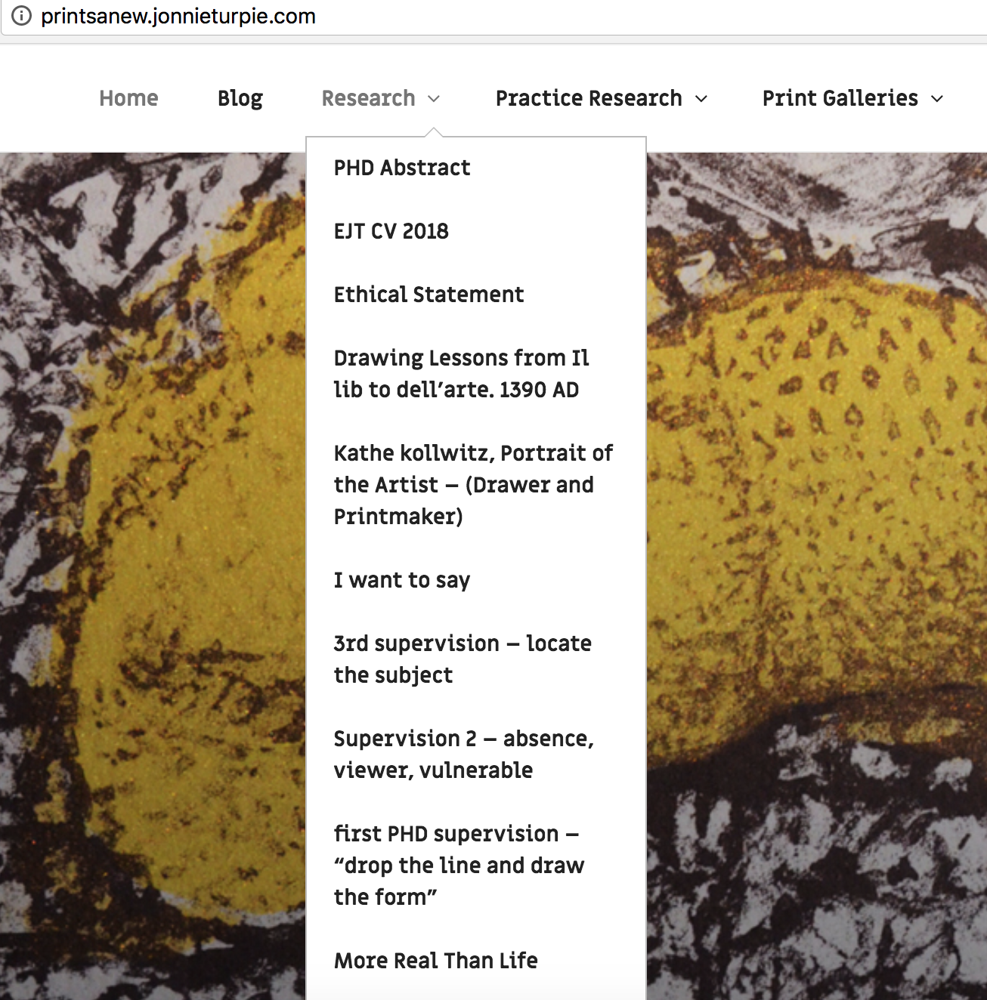
I have developed a dedicated PhD research website to document and track my research development. The site is open to public for general written and practice outputs in the form of artworks. The dedicated PhD Research work is split into two tabs: ‘Research’ and ‘Practice Research’ and are password protected. As well as being an online document repository this is also method of tracking my research development. It also enables sharing of my ongoing findings, thoughts, writing and practice research easily with supervisors.

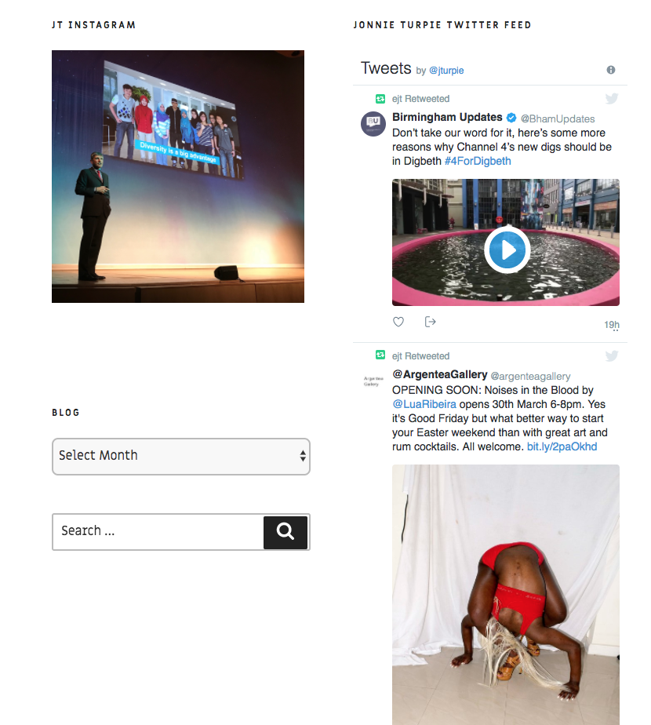
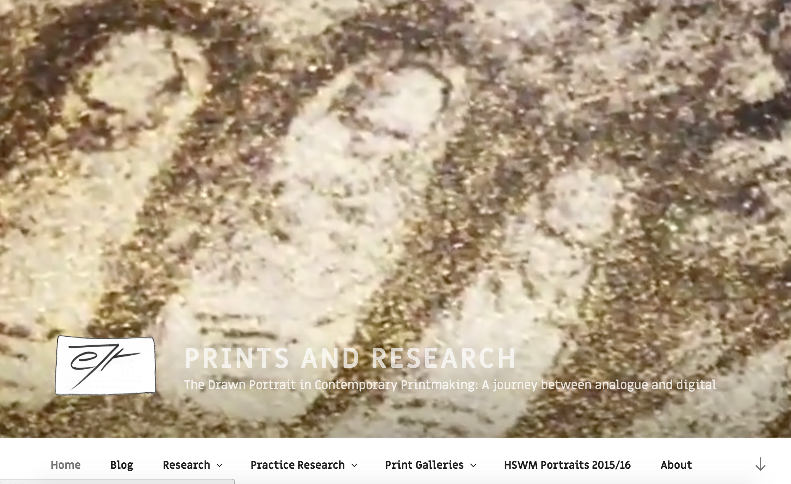

My instagram and twitter channels are connected to the site and enable interaction with users in the field e.g. when attending the PGR Festival. I use the hashtag #PGR_studio in my tweets from cultural and creative industries events.

Practice research
My question is three fold and on every practice artwork exploration I balance all three with their subject specific methodologies. I try, test and assess practice techniques including new digital photography, drawing and print techniques. My research is defining my practice in the context of established drawing and print techniques, and where appropriate describe and name new techniques that I develop. eg ‘mezzoscreen’ describes an amalgam of mezzotint and screen printing that I am developing through investigation into creating backgrounds on mark resist film to draw and scratch into. This research, associated methods and skills development are captured and documented in the Practice Research section of the site in text, images and video. It provides extensive evidence of practice research are here: http://printsanew.jonnieturpie.com

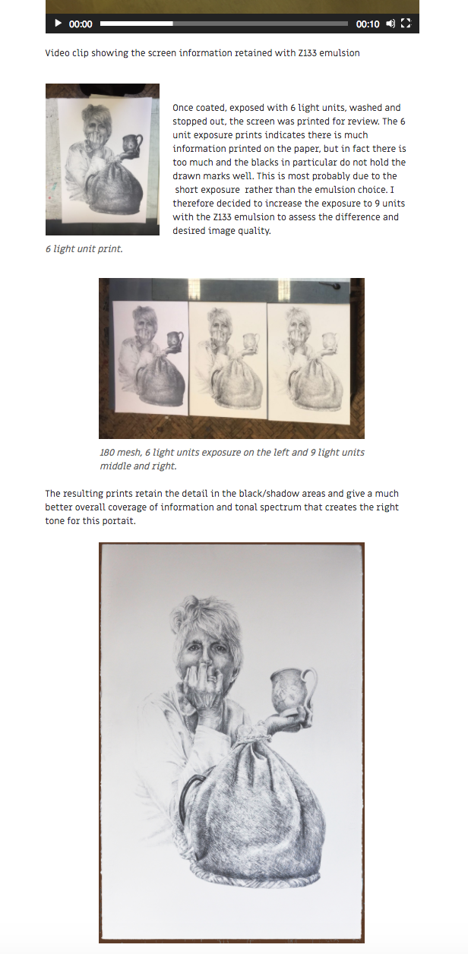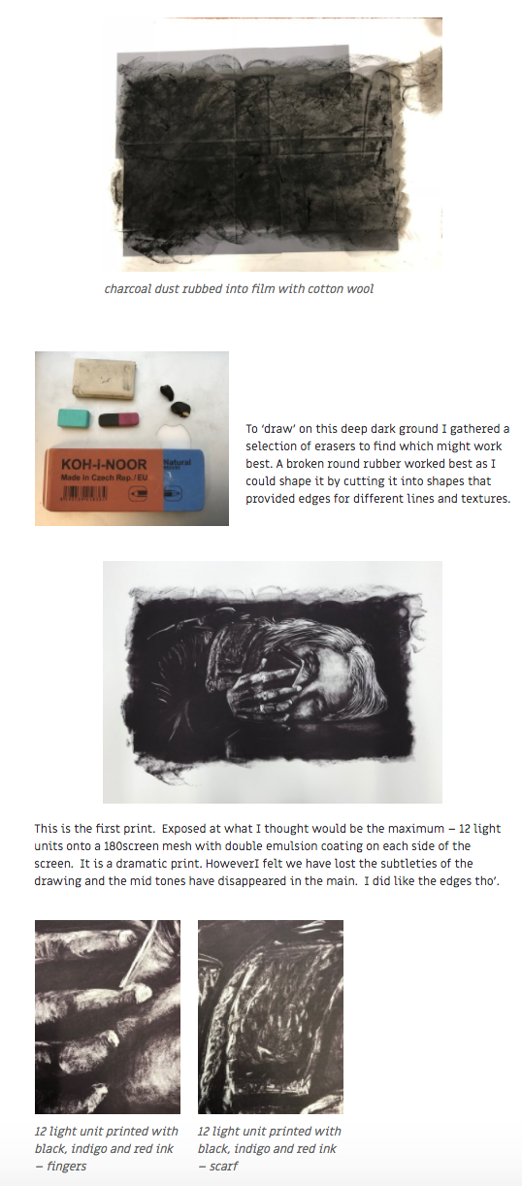

The most recent documentation is : http://printsanew.jonnieturpie.com/rembrandt-huis-printmaking-explorations

Additional practice not directly related to my Research Question, but is beneficial to my extended opportunities include curation, digital drawing and drawing from life.

Curation : I am working with fellow researchers, Artists and Coventry University to curate and project manage a contemporary drawing exhibition and book launch in the International Project Space in the School of Art.

Digital drawing: I am not treating this as a formal part of my practice research, however I regularly draw portraits using this modern medium. These portraits fall into two categories: friends and colleagues I want to celebrate and art gallery viewers.

The first could be termed personal work, which has its rewards in the responses by the subjects which may develop into formal research. The second is a sketchbook for development of drawing, approaches to subject selection and documentation of arts appreciation. It is a space of constant software application development, which is of interest and could become an element for formal research enquiry.

Life Drawing: As a personal challenge to my drawing skills that are framed in my practice research study I have also carried out a series of Life drawing classes to develop my ‘drawing from life’ skills, as opposed to drawing from photography. This is extending my understanding of the range of contemporary drawing. It also provides a learning space for reflection on image making.

Supervision as a method to develop academic and practice research skills and development

The informative and positively challenging supervision input from my Director of Studies, Dr. Catherine Baker has ensured I continue to investigate the premises of my practice alongside extending my established approach to drawing and printmaking. I have learned how to be vulnerable. To reflect and contest my drawing habits, rather than draw and print in secure styles of depiction and representation. I have learned the value of challenging my accepted drawing norms to enable me to select ‘newtome’ mark making methods for particular portraits and extend my drawing abilities. I recognize the value of being open and vulnerable to the research and it the knowledge it affords me. My practice research also addresses the technical and skill base of printmaking whereby I investigate selections of printmaking materials and techniques. I have tested and documented a range of silk screen mesh counts, screen sizes, drawing films, emulsions, inks, paper and exposures to provide a handbook for my research practice.

As a reflective maker I keep track of my development and have extended my supervision session PhD reports by writing reflections on what I have learned, benefited my research and my development as a researcher. My second reflection is here : http://printsanew.jonnieturpie.com/supervision-2-absence-viewer-vulnerable and a summary below, including valuable PGCERT research pointers to ‘doctorateness’ and reflexivity.

Supervision 2 – ABSENCE, VIEWER, VULNERABLE (Turpie.J. 2017)

Dr Baker and I began by reviewing the form drawings that I had made since the first ‘loose the lines, draw the form’ supervision – a hand, a face and a portrait of a young woman concentrating on her homework. My homework was to draw without lines and capture the form of her head. Apart from her (Alex) being my niece I was called to draw her head rather than others in a family gathering because of her concentration, her head and her knotted Taiwaneese hair band, which provided a contrast to her dark hair, in tone, texture as well as emphasising the shape of her head. The drawing began with the cross-hatch drawing of a dark rectangle ground to work from dark to light. This drawing seemed to work reasonably well as it captured her likeness and focus. Dr Baker agreed that this third form drawing had brought a more substantial interpretation, however she asked if I had my drawing ‘kit’. Sadly, I did not have it with me – mistake! – I apologised that I had only one blunt pencil! Another mistake.

Speaking of eyes and isolated body parts, Catherine opened a new sketchbook page, took up an (unforgiving, i.e. un erasable) biro and began drawing early stage heads and suggested I might draw a selected part of a face, rather than automatically assume that a drawing needs to be of the whole head. Perhaps I might look at a subject and leave ‘absences’ that the viewer can fill in rather than be presented with the finished full subject. One of my aspirations might be to ‘encourage the viewer to linger with my artistic outcomes’. Consider the role of the viewer and ways in which, as artists, we can explore mechanisms that encourage audiences to ‘linger with artistic outcomes’.

Last, but not least Dr Baker dropped in a surprising drawing consideration; be vulnerable. I have slowly understood what she meant – be open to risks, new drawing techniques and ways one is seeing and reading the subject and the light that is describing it. Make yourself vulnerable during drawing. Do not always stick to what you ‘know’, let oneself be taken by the subject and your interpretation through the actuality of your drawing of it. This, like so much of what I am experiencing in this early phase of my research is ‘newtome’. It is challenging my drawing capabilities, and it has to be said my psychological understanding of what is at the basis of my image making in the journey(s) between digital and analogue contemporary portraiture.

This notion of vulnerability in practice and reflexivity is enabling me to develop as a practice led PhD researcher.

In this context I am exploring the question of ‘Epistemological Ambiguities’ that has risen in my desire to capture responses to photographic portraiture that do not rely on textual contextualisation but on the photographic practice that will feed into the digital smart phone methodology element of my research. The term ‘Epistemological Ambiguities’ has been pointed to by Dr Jacqueline Taylor through the PGCert programme. Her draft paper: Research-practice-pedagogy: Establishing new topologies of doctoral research in the arts (Taylor.J. 2017.4) includes this definition:

“The epistemological ambiguities of art-based research remain a contentious issue within the academe; often perceived as either elusive or incomprehensible as such research is not easily reconciled with more traditional notions of academic research (Nelson 2013: 4). In the context of the PhD, this is largely because one of the qualities of ‘doctorateness’ is that it is a contribution to knowledge and there is an expectation that such knowledge(s) must be clearly communicable. However, in a similar vain to the performative paradigm Brad Haseman elucidates, that artists often ‘begin something without knowing how it will turn out’ is a core aspect of what drives the creative process (Fisher and Fortnum 2013: 7). Artistic practice instead produces knowledges that happen in a ‘unique material and specific way’ that cannot generically be mapped onto other fields or works of art (Vincs 2007: 11). Rather, it can be perceived to be a form of ‘material thinking’ or ‘praxical knowledge’ that arises through the material handling in practice (Bolt 2007: 29). However, difficulties arise in articulating research where this tacit and slippery knowledge is embodied in process and visual, material and performative art forms, eluding normative signifying structures and communicative language.”

‘This in the context of the PGCert : The PgCert can be seen to function as a threshold space for PhD students at the beginning of their doctoral journey to (un)think what they think they know, raise vital epistemological questions in negotiating practice and theory and question what research itself may mean and become.’

Vulnerability is an attribute I have learned is something a practice based researcher must embrace if one is move forward and develop. Being vulnerable. Being open to ‘unthinking’ what I know. Being open to failure, or more precisely being open to learn from failure.

Ethical Statement.

As surreptitious smart phone photography is core to my research I reviewed the University Ethical Statement questions and realised I could not answer all of issues raised. I took the opportunity to address the areas of doubt and responded with a comprehensive Ethical Statement and submitted to Dr Lawrence Green.

Ethical Statement.
The final statement is included in this submission.

Intended methodological approach
I seek to continue to balance and develop theoretical and practice research methodologies that I have described in this submission and assignment.

Proposed research plan
I will maintain and develop the practice research, expand and refine academic study and writing as per the Gantt forward plan. This plan captures my research intentions over the PhD research period. It covers a responsive and reflective academic and practice research timeline to ensure I am open, but focused. The breadth of my research will have to be regularly reviewed and (re)structured when required. I have come to understand that research is a fluid process that shifts and responds as new discoveries are revealed. I intend to respond to such movement through reflective evaluation in order to drive my research activities into new areas of enquiry. It also captures the outward expression of my research in terms of conference attendance and paper submissions

Gantt Chart Forward Plan. Is Attached.

References :

Thompson.D. 1933. Il lib to dell’arte Cennino D’andrea Cennini. The craftsman’s handbook. translated daniel v Thompson Dover pubs

Turpie.J. October 2017. http://printsanew.jonnieturpie.com/supervision-2-absence-viewer-vulnerable

Taylor. J. 2017: Research-practice-pedagogy: Establishing new topologies of doctoral research in the arts (draft)

Ethical Review

Ethical Review of Research, Self Assessment Form. Stage 2.

The Drawn Portrait in Contemporary Printmaking:
A journey between analogue and digital
This research explores the value of using contemporary smart phone digital photography as a basis for portrait drawing, printmaking and how this process alters the meaning of the image.
It is my intention to interrogate the question through the digital and analogue techniques of image making and by exploring the complex relationship between the observer and the observed entity.

I very much welcome this opportunity to question the ethical basis of my research as it is core to the starting point of the study.

Having answered Yes to a number of questions in Ethical Review Stage one I submit the following stage two answers .

- Will research project involve humans as subjects of the research (with or without their knowledge or consent at the time) i.e. Including all interviews, observational activities, focus groups, questionaires, access to or generation of records relating to humans.

Yes

I discretely take smart phone pictures of people that may become source material for a work of art.

- Is the conduct of, or the results of the research project likely to expose any person (yourself, participants or others) to physical or psychological harm?

NO – further explanation :

If a human being is to be used as source material for a portrait I create it is to celebrate the subject, not to denigrate nor besmirch their person or reputation in any way.

My intention is always, where possible, to inform the subject that the art work has been created and indeed is offered a print of the work for theirown keeping.

I have never had any subject complain to me that they have been misused, interpreted or damaged by the works that have been created. In fact everyone who I have been able to share a work that they have been the subject of is pleasantly surprised and very happy to have been an unknowing subject. People close to them have on occasion said that the portraits capture something of the person that is core to their personality and therefore of value to both subject and those close to them. Responses have included ‘thank you for doing me the honour of making a portrait of me”; Greg Lowson “I love this” Lara Ratnaraja; “You have captured him exactly as I know him” (Ann Towe of her husband Stewart Towe OBE’s portrait); “You have really caught me so well”. HJJ Mrs Mary Stacey; Pauline Bailey “I had no idea thanks“ Pauline then made her portrait her Facebook Profile Picture.

A number of subjects have bought their portrait to be exhibited in their surroundings.

Informed consent. And right to withdraw.

It is after the event of photography and subsequent drawn and printed portrait, that consent is saught. This enables the candid image to be the basis of a portrait that captures and reflects the subject in a manner that cannot be achieved by pre consent agreement. Pre consent agreement would make the subject aware that they are being selected for a portrait and therefore present themselves in a way they feel appropriate, which may deflect from their ‘usual’ persona.

I have extensive experience of attaining consent for participation and contributing to mainstream media production where it is imperative that consent is attained as a contribution cannot be broadcast unless consent is given. At the onset of my television career I was called to the High Court to answer/present the case that I as the producer director of a television current affairs programme had gained consent by a contributor to ’stand up’ a serious allegation made against a member of the press. Following a 24 hour period of grace and a 200 mile overnight round trip to the contributor’s home to provide a signed affidavit of confirmation of statement and consent for the court the Judge found in my and the broadcaster’s favour. Since that event I have always ensured that consent by contributors is given to productions I have had responsibility for. This has meant providing the signed ‘Release Forms’ that are lodged in the Commissioned Programme documentation required by a broadcaster before transmission can be ‘legalled’ and go ahead.

I have also produced and directed a number of Television Dramas using collaborative methods whereby contributors to a fiction about their lives are fashioned through processes of devising and scripting. These are complex processes that drama producers in the main avoid as they are time consuming and may take away from the writer’s and director’s auteur vision. I would argue that collaboration with filmmakers, writers and their subjects brings a ‘reality’ to drama films that provides a ‘more’ honest representation that is signed off by contributors.

It is with this experience and knowledge that I have begun my practice based research as an Artist, rather than TV producer. For some time I have felt that although ‘release forms’ are signed and consent is given, the contributor may not be fully represented through the editing process. It is nigh on inevitable that elements of a contributor’s contribution, that they have agreed to be used following the interview recording, will be lost during the post production process.

So as an Artist I want to find the most honest methodology to create the fullest portrait of a human being I can. I am tussling on a daily basis with the most ethical means to adopt to create these portraits. This is core to my research in which I always consider very carefully if I should take a photograph in the first instance, and then whether I should proceed to the next stage of drawing my interpretation of that person. I also consider if there may be societal and cultural norms that may pertain to a particular subject that would make me question whether I had the right to embark on a portrait. These considerations will then be shared with the subject whenever possible when a portrait has been made and I am content it reflects the subject I have met.

Current Case Studies : Most recently I made portraits of 3 people I have met involved in the Arts – Professor Elaine Shemilt; Courtauld Student Katie Bannister and her cousin Bea and photographer Paul Kenny. I was clear about two images I wanted to draw and print but I was having difficulty in selecting the ‘one’ smart phone discreet photograph to make a drawn and printed portrait of the photographer Paul Kenny. In the end I made three very different portraits and shared with the subject.

http://printsanew.jonnieturpie.com/new-summer-2017-prints

The responses when I shared the portraits with the subjects were:

Professor Shemilt : Wow Jonnie, That’s amazing! Thank you very much,

Katie Bannister: ”Thank you very much. It Means a lot, really it does.”

And Paul : I'm flattered, both by the kind words and the images. I feel it's only fair to be honest, two of them I really love and feel they are "me", the middle one I'm not so sure about ...I think I look a bit like an insane Michelin man.....you've caught all the things about myself I hate...but I suppose that's what portraits are about.

I feel I may decide not to exhibit the portrait Paul is not happy with, but first I will take the prints to him so he can see the reality of the large scale drawing on quality paper. Whatever the outcome I will have followed through an honest and transparent ethical procedure to ensure no one is harmed by my practice based research. In fact I hope they are emboldened as people in themselves by the fact they have been selected to have a large scale drawn portrait of themselves that captures and reflects something akin to their being.

I am researching as part of my PHD examples and considerationof photographers that have used hidden camera to create their art, including Thomas Struth (Museum Pictures), Beat Streuli (New Street), Luke Delahaye – (portraits) ; Walker Evans and Dorthea Lang and Eudora Welty for the American Works Progress Administration and later Evans ‘Subway passenger portraits’, Bruce Davidson’s 1970s Subway and “in their face’ street portraiture of Magnum photographer Bruce Gilden.

- Will you have access to personal information that allows you to identify individuals, or to corporate or company confidential information (that is not covered by confidentially terms within n agreement or by separate confidentially agreement)?

Yes and No. By virtue of making a portrait of a human being one is identifying the subject. NO I will not be gathering or disseminating any confidential information.

- Will your research include a requirement to present or retain personally identifiable information about individuals (images or written records)

Yes and No . As images of human being are the starting point for portraits in this research I will be presenting personally identifying information. No I will not be making written records of the subjects beyond the publically available information and title.

Questions 5 -10 answer NO

As part of my research I will track the issues above to monitor the ethics of the project as it progresses to ensure that if the research changes direction ethical considerations will similarly be taken account of and be reported upon. This will encourage notification of any unanticipated consequences. All participants, collaborators and contributors will be informed and be acknowledged in public dissemination of the research and its outputs.

Additional project information from my proposal:
The smart phone is a ‘natural’ item of 21st century human apparel. It has been said we are now ‘Phono Sapiens’°: The Economist. Across the planet smart phones have quickly become ubiquitous and the adoption of this transformational personal technology invites us to ask questions of the society that uses and adapts to them. Historically portraiture subjects are complicit with the artist and pose for the event, however with the smart phone camera the subject is unaware of the artist begining a process of portraiture. While the subject goes about their daily life the artist observes and discreetly ‘captures’ the most relevant and appropriate moments to form the beginnings of a portrait. At this early stage the Printmaker is a discerning digital photographer imagining the future analogue printed interpretation.
This journey to the printed portrait raises questions of voyeurism, documentary photography and artistic interpretation in an increasingly ‘transmedia’ environment. Susan Sontag* drew our attention to these issues when she argued that the proliferation of photographic images had begun to establish within people a “chronic voyeuristic relation” to the world around them. Among the consequences of photography is that the meaning of all events is leveled and made equal. My research will take these questions forward by asking What are the early 21st Century digital and analogue techniques and tools that can positively add to new approaches to portraiture?
Process analysis
The printmaker embarks on the journey to create a photographic led portrait by selecting a single image, applying subjective criteria such as: angle, action, gesture, character, atmosphere, light and shade. This process is akin to selecting one image from a contact sheet to ‘develop’ further. Once selected the printmaker continues in the digital imaging world to refine the imagined portrait through cropping, alignment, light and shade alterations until content with a starting point for the analogue drawing. “Creating an artwork – a painting, drawing or a print – means isolating visual problems that need solving.” * Deborah Wye
Elements of the digital image are disregarded in favour of the essential elements of the subject as decided by the artist. The elements of a photograph that ‘fix’ the subject in place and time are disregarded, freeing the subject from signifiers that are core to the ‘realism’ of the photographic image. Progress towards the analogue portrait brings choice of print technique (intaglio, silk screen, lithography, monotype, digital); choice of marker (pencil, crayon, graphite, ink, brush, stylus, scalpel) and texture of drawing surface, (film, paper, digital screen, plate) are among the first artistic of many inter-dependent decisions.
Through analysis and practical print construction I will investigate and evaluate how issues of portraiture originating in the digital world can change the status and meanings of the image as it is interpreted in the analogue world.
The current progress of the research is captured on the project website : http://printsanew.jonnieturpie.com

The Project proposal in full is here : http://printsanew.jonnieturpie.com/phd-abstract

If passwords are required for sections please contact me and I will supply.

Literature Review

My literature review has been broken down into the main question of study: Contemporary Portraiture, and the 3 practice based domains of ‘digital Photography’; ‘Drawing’; ‘Print Making’. These strands with their own paths, structures, dynamics and histories will be collated to form an integrated knowledge base to provide the foundation for the overall research plan.

I shall continue this exploration of practice and theoretical research until I have satisfied myself, and peers, that the research has reached an academically robust stage. At that point I will bring together the three stands under the overall question and address, through my research activities and acquired knowledge, what Contemporary Portraiture means when considered in analogue and digital domains and the implications to practice and expanded image-making processes.

The literature review has been utilised in the writing of my initial research : Getting it Right : Contemporary Portraiture - doing justice and the maker in the made.

Drawing :

Thompson, D.V., 1933. The Craftsman's Handbook: Il Libro dell'Arte Cennino d'Andrea Cennini. New Flaven.

Petherbridge, D., 2010. The primacy of drawing: histories and theories of practice. Yale University Press.

Cain, P. 2010. Drawing: The enactive evolution of the practitioner. Intellect Books.

Malsen, M. and Southern, J., 2011. Drawing Projects-An Exploration of the Language of Drawing. Black Dog Publishing.

Hockney, D. Secret Knowledge. Rediscovering the Lost Techniques of the Old Masters. Thames and Hudson, London, 2001 ISBN 0-500-23785-9.

Photography

Scharf, A., 1974. Art and photography. Penguin.

Berger, J., 2013. Understanding a photograph. Penguin UK.

Phillips, S.S. ed., 2010. Exposed: Voyeurism, Surveillance, and the Camera. Tate Pub..chapter Simon Baker.

Phillips, S.S. ed., 2010. Exposed: Voyeurism, Surveillance, and the Camera. Tate Pub..Sandra Phillips Voyeurism and it's affinities from the beginning of photography.

Keller, J., 1993. Walker Evans and many are called: Shooting blind. History of Photography, 17(2), pp.152-165.

Walker Evans and Dorthea Lang and Eudora Welty for the American Works Progress Administration

A Pre-Raphaelite partnership: Dante Gabriel Rossetti and John Robert Parsons. Colin ford Burlington magazine . May 2004, No. 1214 – Vol 146

Printmaking, drawing and photography

Rembrandt and Schwartz, G., 1977. The complete etchings of Rembrandt: Reproduced in original size. Dover Publications.

Kathe kollwitz – Portrait of the Artist printmaker .
IKON and British Museum Catalogue isbn: 978-1-911155-14-0
McCausland, E., 1937. Käthe Kollwitz. Parnassus, 9(2),

Prelinger, E., Kollwitz, K., Comini, A. and Bachert, H., 1992. Käthe Kollwitz: National Gallery of Art, Washington (3.5.-16.8. 1992). Yale University Press
Tate Vija Celmins video interview : https://www.youtube.com/watch?v=ZbA5qTOB1mI

Chuck Close. Blood Sweat and Tears. Kirke Varnedoe. 2002 534 W,25th St NY

Chuck Close interviews Vija Celmins Artspace : https://www.artspace.com/magazine/interviews_features/book_report/chuck-close-in-conversation-with-vija-celmins-about-her-dense-yet-infinite-drawings-54732

The American Dream - Stephen Coppel, Catherine daunt, Susan Tallman.
British Museum Thames and Hudson 2017
Screenprinting. Jane Sampson. Google books April 2017 : p74 https://books.google.co.uk/books?id=O0klDwAAQBAJ&pg=PA74-IA55&lpg=PA74-IA55&dq=mark+resist&source=bl&ots=FnfsmJPHr3&sig=e1vRG7iGHxXWVcsewrVD3qJz8iY&hl=en&sa=X&ved=0ahUKEwjtjs6A5ujXAhXJJcAKHRCPD7I4ChDoAQgyMAA#v=onepage&q=mark%20resist&f=false
Printmaking techniques : https://www.handprinted.co.uk/

Morton, M., 2017. Max Klinger and Wilhelmine Culture: On the Threshold of German Modernism. Routledge.

William Kentridge reflects on this in ‘Double Lines’ . Five Themes’ referenced by Ed Krama in : Cinematic Drawing in a Digital Age.Tate Papers no.14http://www.tate.org.uk/research/publications/tate-papers/14/cinematic-drawing-in-a-digital-age
PeterRobb. https://www.theguardian.com/education/2001/oct/20/highereducation.news

Portraiture

Woodall, J. ed., 1997. Portraiture: Facing the subject. Manchester University Press.

Cumming, L., 2009. A face to the world: On self-portraits. HarperCollins UK.

West, S., 2004. Portraiture. Oxford University Press.

Zöllner, F., 2000. Leonardo da Vinci, 1452-1519. Taschen.

Thompson, D.V., 1933. The Craftsman's Handbook: Il Libro dell'Arte Cennino d'Andrea Cennini. New Flaven.

Van Kruiselbergen, A., 2013. Breakfast with Lucian Geordie Greig.

Lucian Freud. Catalogue. William Feaver. Tate Publishing 2002

Schama, S. and van Rijn, R.H., 1999. Rembrandt's eyes (p. 329). New York: Alfred A. Knopf.

The Vasari Corridor & its Self-Portrait Collection
https://en.m.wikipedia.org/wiki/List_of_self-portraits_in_the_Uffizi_Gallery

Laura Cummings, Observer Review Dec 19th 2017
Interview with Jenny Saville. Elena Cue. Huffington post 2016https://www.huffingtonpost.com/elena-cue/interview-with-jenny-savi_b_10324460.html

Ethical Consideration
Matt Crowley – Soul Theft through Photography
Identical Twins – Not Identical Brains. Professor Eric Kandel. DNA Learning Centre. https://www.dnalc.org/view/1200-Identical-Twins-Not-Identical-Brains.html
Francis Bacon. Use of Photography http://francis-bacon.com/life/family-friends-sitters
FACE Bruce Gilden photographs. Daniel Lewis publishing 2015
WNYC Street Shots: Bruce Gilden. https://www.youtube.com/watch?v=kkIWW6vwrvM

Philip-Lorca di Corcia (Heads)
- (-) https://thephotographyblogger.wordpress.com/2011/03/27/famous-photographer-series-philip-lorca-di-corcia-heads/
Matt Crowley – Soul Theft through Photographyhttps://www.csicop.org/sb/show soul_theft_through_photography s
William Greenwood. The new Arab. Images and idols. The figurative in Islamic Art. Central Islamic lands at the museum of art in Doha.
https://www.alaraby.co.uk/english/society/2016/7/26/images-and-idols-the-figurative-in-islamic-art
Alvin Lamb ; 2016 https://www.quora.com/Did-you-ever-feel-like-quitting-social-media-When-and-why
Ricardo Moraes. Photos for gaining trust to deliver positive medical interventions in Kayapo culture in Brazil. http://blogs.reuters.com/photographers-blog/2011/05/12/capturing-souls/ May 12, 2011.

NON utilised literature references review

Simmons, L., 2014. " Drawing has always been more than drawing": Derrida and disegno. Interstices: Journal of Architecture and Related Arts. NON

Hannan Al-Obaid : The Philosophy of Islamic Ornament in Islamic Art. Department of English, Communication and Philosophy University of Wales September. PHD Thesis. 2005 NON

21st century portraits – national portrait gallery. Andrew Graham Dixon, Jo Higgins, Sarah Howgate, Sandy Nairne NON

The Naked Portrait: National Gallery of Scotland. Martin Hammer. ISBN 978 1903278956 NON

Wilde, O., 2003. The picture of Dorian Gray. Penguin. NON
Barthes, R. and Howard, R., 1987. Camera Lucida: Reflections on Photography. New York: Hill and Wang. NON

Hustvedt, S., 2016. A Woman Looking at Men Looking at Women: Essays on Art, Sex, and the Mind. Simon and Schuster. NON

Di Pippo, A.F., 2000. The concept of poiesis in Heidegger’s An introduction to metaphysics. Thinking fundamentals, 9. NON

Andrea Büttner Beggars and iPhones . Catalogue. 2016 Kunsthalle Wien GmbH .Vienna ́s exhibition space NON

Cubitt, S., 2014. The practice of light: A genealogy of visual technologies from prints to pixels. MIT Press. NON
Thomas Struth Photographs 1978 -2010. Ed . Annette Kruszynski, tobi bezzola james lingwood Monacelli Press NON

Davidson, Bruce, Fred Braithwaite, and Henry Geldzahler. Subway. Steidl, 2011. NON

Benjamin, W., 2008. The work of art in the age of mechanical reproduction. Penguin UK. NON

Fried, M., 2008. Why photography matters as art as never before (p. 409). New Haven: Yale University Press. NON

Coming to Light Birmingham’s photographic collections. Ed Peter James ISBN 0709302282 Birmingham museum and art gallery. Birmingham Library NON

Newhall, B. 1964. The history of photography from 1839 to the present day.; Book. NON

Anatomy for the Artist. Drawings Tom Flint. Ed Peter Stanyer. Acturus. ISBN 1-184193-073-3 NON

Brassaï, 1976. The Secret Paris of the 30's. Pantheon Books. NON

Vietnam Inc Philip Jones Griffiths Macmillan. Collier books NYC. Lib of congress73-167932 NON

Thomas Bock – IKON ed. Jenny Stewart and Jonathan Watkins and Cornerhouse. isbn: 978-1-911155-17-1 NON (used with blog)

Portable Studio – Trevor Appleston : Publisher: Booth-Clibborn Editions (31 Oct. 2017)ISBN-10: 1861543808 NON

Poiesis and Art-Making: A Way of Letting-Be. Derek H. Whitehead

Sometimes, working hard is not enough – Poiesis and Praxis NON

Cumming, L., 2009. A face to the world: On self-portraits. HarperCollins UK. NON

Luke Delahaye – (portraits) NON

Beat Streuli (New Street) IKON NON

ED VAN DER ELSKEN

van-der-elsken. CAMERA IN LOVE. https://www.stedelijk.nl/en/exhibitions/ed-van-der-elsken-camera-in-love NON

Illuminating photography: From camera obscura to camera phone - Eva Timothy https://www.youtube.com/watch?v=XaGUL8B-BrE NON

Abbott, B., 2010. Engaged Observers: Documentary photography since the sixties. Getty Publications. NON

Maloney, M., 2001. I am a camera: the Saatchi Gallery. Booth-Clibborn. NON

Berger, J., Savage, J. and Savage, J., 2005. Berger on drawing. Aghabullogue, County Cork: Occasional press. NON

Research Forward Plan is attached as separate excel document.

This question is couched in 19thC drawing term, rather than those of contemporary drawing.
. Artistic photographers and champions of the medium as it matured over the coming century will have rightly claimed similarly that the mind is at work in their image making.

