First supervision with director of studies Dr Catherine Baker - ‘drop the lines and draw form’

Practical demonstration :

Create a background with pencil cross hatching in all directions and gently smooth over the graphite with an eraser to ‘flatten’ down the graphite into the paper to create a dark ground, rather than the white of the paper. This gives the opportunity to create form and light from the dark, rather than delineating the form by the drawn line.
Begin drawing into the paper to create light and shade for the form of the face, eye, nose, mouth etc and for highlights do not be afraid to use the ‘sharpened’ dreamer to rub away the graphite ground to make for the light.

Dr Baker also pointed to a range of ‘drawers’ that use different techniques to capture form; some artists, some anatomical, some architects and Giacometti’s portraits, Ewan uglow, Ching, Emma Stibbon, Sarah Simblet

Giacometti’s portraits

http://aseparatepieceart.blogspot.co.uk/2008/07/article-giacometti-drawing-technique.html
Book James lord : https://www.amazon.co.uk/Giacometti-Portrait-James-Lord/dp/0374515735
Film : https://www.theguardian.com/film/2017/feb/11/final-portrait-review-geoffrey-rush-shines-in-stanley-tuccis-witty-giacometti-sketch

Ewan Uglow

http://www.tate.org.uk/art/artists/euan-uglow-2084

France d k Ching

http://www.frankching.com/wordpress/

Emma Stibbon

http://arts.brighton.ac.uk/staff/emma-stibbon

Sarah Simblet

http://www.rsa.ox.ac.uk/people/sarah-simblet

Having looked at the work of these drawers I returned inspired to the studio with my sketchbook double page spread to contemplate. Rather than return to my drawing for prints that are in progress I took Catherine’s advice an began prepared a page with graphite cross hatching and rubber skimming. My most recent portrait for print was of an expert guide from the Rembrandt Huis who held up a drawing in her left hand and outstretched her right hand to emphasise her words of enthusiasm for the work, made by Rembrandt in the self same surrounding her audience were standing in.

I looked again at her outstretched hand and began a drawing of form, rather than line deliniation drawing.

Rembrandt guide hand.

The following day I reviewed the hand drawing and embarked on a second form drawing, a partial portrait of Herman, a craftsman that has seen my printed drawings and looks forward to my drawing of him. Perhaps this form drawing will be the start of that printed portrait.

Herman :

While drawing my mind took me to the drawings of Leonardo da Vinci and how he used his myriad of drawing skills and techniques to represent form.
I turned to Leonardo sketches and drawings. (Frank Zoller. Professor of medical and renaissance art. University of Leipzig.)

Seeing and reading about Leonardo’s pencil, metalpoint, chalk and crayon drawings of human, animal, anatomical and scientific drawings brought me to a chapter on drapery studies :
(Drapery Studies Johannes Nathan institute of art history at berne University.) Page 54

While discussing the attribution of drawing and painting to Leonardo Nathan notes that cross hatching by a left handed is top left to bottom right and a right handed is : top right to bottom left and that from time to time in these drapery studies Leonardo created dark grounds.

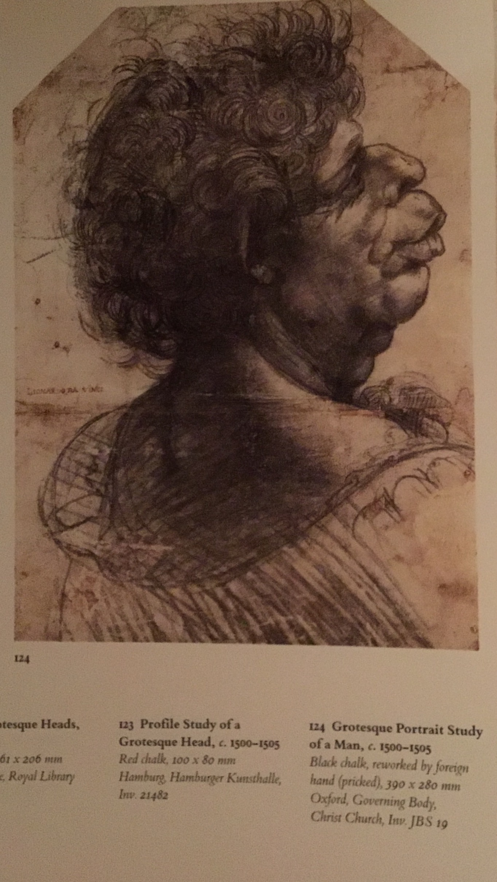
‘These studies are all executed on linen which meant they could not be worked using the usual materials crayon or pen but only with a brush. The linen was first evenly coated brown and grey preparation, moreover, meaning that the draughtsman had to work from dark to light. After first laying down those outlines and areas of shadow in black, the study had to be built up in lighter shades, finishing off with white heightening. This method of working is this the very opposite of the usual drawn it by hand, for on paper the areas that are the lightest are mostly those that have been left blank, whereas the dark areas are those of particularly heavy sketching. ‘

He quotes Giorgio Vasari, when apprenticed to Leonardo:”Leonardo sometimes made clay models dripping the figures with rags dipped in plaster, and then drying them painstakingly on fine rhiems of cloth or prepared linen. These drawings were done in black and white with a point of a brush, and the the results were marvellous.” Vasari goes on :”One of the remarkable aspects of Leonardo's talent was the extremes he went to, in his anxiety to achieve solidity of modelling, in the use of Inky shadows. Thus to get the darkest possible grounds Leonardo selected blacks that me depressed shadows of mine did blacker than any other, endeavouring to make his lights all the brighter by contrast.”

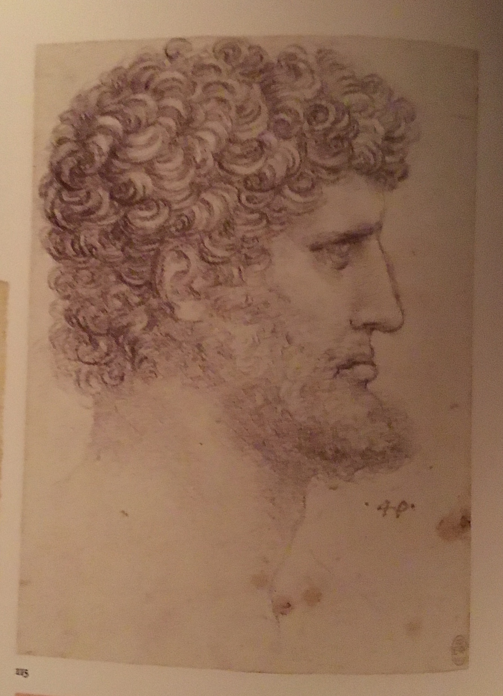
Vasari is further quoted in the 2015 Courtauld Institute exhibition : Drawing as a means of artistic expression

“… what design needs, when it has derived from the judgement the mental image of anything, is that the hand, through the study and practice of many years, may be free and apt to draw and to express correctly with the pen, the silver point, the charcoal, the chalk, or other instrument, whatever nature has created.”

Vasari, “Of Painting”, in Vasari on Technique, transl. L.S. Maclehose, London, 1907, 206.

Leonardo used many drawing techniques to create form including ‘pen and ink over black chalk’. I cannot find any documentation by him about this technique at present, however there is much to be researched. It seems that a Italian artist and author born in 1370 wrote a seminal technical handbook for the apprentice artist that even Leonardo may have consulted. Cennino Cennini ‘Il Libro dell’Arte.

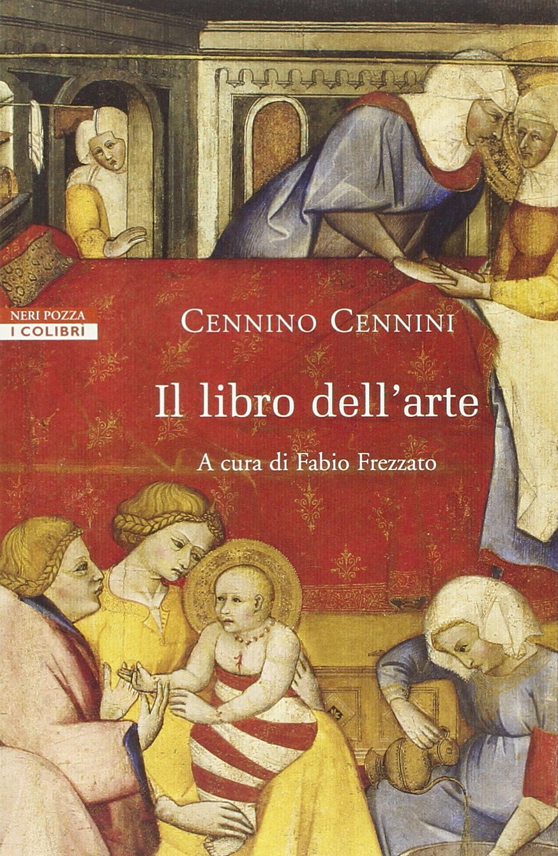
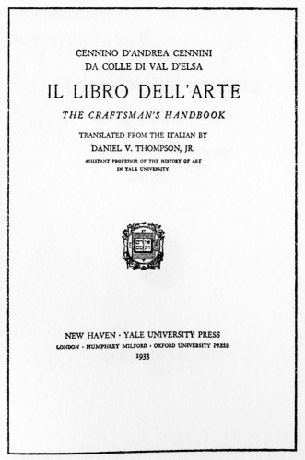
It Translated into English under the title 'The Craftsman's Handbook' by D.V.Thompson (1954), it is an invaluable source of information about all aspects of the craft of the late medieval painter's workshop and techniques.

Further reading and researching :

Carman c bambach’s

Leonardo Da Vinci Master Draftsman: Catalogue to an Exhibition at The Metropolitan Museum of Art, New York 2003
https://books.google.co.uk/books/about/Leonardo_Da_Vinci_Master_Draftsman.html?id=QwQxDJMKRE4C&printsec=frontcover&source=kp_read_button&redir_esc=y

http://catdir.loc.gov/catdir/samples/cam032/98051727.pdf

Drawing form and the attention to drawing techniques collated by Ceninno Cellini 'Il Libro dell'Arte’ takes me to Michelangelo whose:

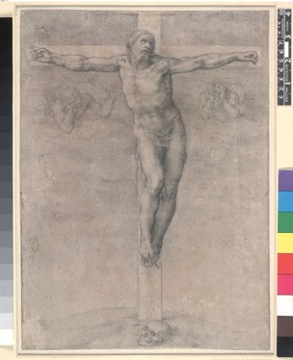
“near total renunciation of the medium (Pen) in favour of black chalk in the last thirty years of his life. His preference for black chalk even extended to architectural studies, a category of drawing that his contemporaries overwhelmingly preferred to make with the Pen. … … The density of black chalk meant that Michelangelo could press hard down on its sharpened tip to emphasise the torsion of the muscle or register of the density of bone, while the same stick of chalk could also create modulated hatching of the utmost delicacy, as in the British Museum crucifixion drawn as a gift in the late 1530 or early 1540s. Miraculously smooth transition of tone in the latter drawing was achieved through dexterous and time-consuming employment with a finger or a stump, a roll of leather or cloth with a domed point, in order to blend the modelled areas of chalks together seamlessly, a technique found in earlier studies such as the Harlem bathers.”

Michelangelo drawings: closer to the master. Hugo CHAPMAN British Museum and Yale university press.

This is week one of my Research is feeding into my thinking on :

When to use line and shading

What paper to use for further form drawings.

What additional media can be sourced for drawings for print.
How to progress current drawing for print Serota: drawing on mark resist for silk screen printing

