Developing as a researcher
Abstract
The contents page below captures the range of information I submit as evidence of my development as a researcher. Also evidenced is my critical reflection on how these activities inform my learning and developing research practice. As a practice-led researcher I have arranged the balance of theoretical and practice research to ensure both are rigorous and complement each other. I address each heading with evidence of development and delivery drawn from my attendance and participation with the PGCERT Course and subsequent development as a doctoral research student. In addition, I provide evidence of attendance and my implementation of supervision input from my Director of Studies and Second Supervisor in academic and practice research. Through this evidence I have documented the range of research skills I have gained and will build upon as my ongoing research activities reveal new avenues to be explored. I seek to show that I understand the needs, structures and deliverables of doctoral research study. I communicate how I am engaged in the challenges of practice-led research and the journey in front of me, as I build knowledge in my selected domain of Contemporary Portraiture in digital and analogue environments.
Contents:

Critical reflection: Academic writing

Evidence of development: Research skills and resources

Ethical enquiry and statement

Extended academic writing skills

Digital public and private repository

Practice-led research

Supervision as a method to develop academic and practice research skills and development.

Supervision 2 – ABSENCE, VIEWER, VULNERABLE

Practice research challenge and methodological pursuit
Action plan for development
Research plan.

Academic Writing: Critical reflection

As a new researcher I had an initial apprehension about my ability to write a thesis. In the first weeks of study it is a daunting prospect. As a mature student from a creative industrial career my writing skills were geared to fast turnaround pitch documents rather than considered, scholarly writing. In tandem my practice research was driving me forward and providing rewards following supervision input. PGCERT meetings were a welcome weekly reminder of the academic task ahead and an opportunity to share and learn from experienced researchers, educators and peers.

PGCERT Week Six: The Writing retreat. It sounded very romantic; writing in the country? It was actually a very practical city-based day, facilitated by an experienced and pragmatic writer where I, with my research colleagues, rose to the challenge to write in response to the topic “ I Want To Say.”

It was a well-structured day. The process was to write for 5min, discuss, 5 min, write 5min, reflect. Go again for 20min, no discussion. Stop. Reflect. Write again. 20 min repeat. The resultant 2000 words of un-formatted thoughts, provided foci and concepts including the core driving questions and issues for the ensuing research. It brought valuable confidence and a method to get thoughts down on paper, at speed. It also brought inspiration to write further and synthesize into strands of research. I reviewed the 2000 words, honed and extended areas and added a conclusion.
“An early reflection: I WANT TO SAY…………. At the beginning of my research I want to say that drawing is a personal activity that makes the world appear on paper.” The resultant 2500 words provided the material to share with supervisor’s my early clambering’s for academic research writing capability. Supervisory feedback pointed me towards what academic writing demands, rather than my, from time to time ‘outlandish claims’. “You are a doctoral research student and must be able to point to existing knowledge relevant to your pursuit of new knowledge.”
Subsequently, I have learned to apply critical analysis and substantiate any claims through reference to high quality, peer reviewed, published works. The redraft included additional references to on line articles and relevant blogs that brought current thinking on digital issues. The redrafted first section is here:
http://printsanew.jonnieturpie.com/i-want-to-say

My academic writing skills are developing and through application, review and feedback I am confident they will develop further as they have done so far. I now understand the importance of providing a theoretical anchor to points raised throughout my research activity which, in turn, adds a critical and valuable authoritative voice. I have learned these skills which have given me more confidence in framing and presenting my research materials to multiple research communities.

Research skills, resources and researcher development
I have learned how to use google scholar and the Harvard referencing system, which I have applied in my early research writing. I am signed up to a number of research networks through the jisc platform including drawing research, printmaking and digital culture. I use the BCU Library system and have seen the value of the interlibrary loan system when recently seeking Cennino Genninin’s artist’s handbook 1390. (Thompson, D.V. 1933.) It was not available locally but was sourced from the British Library. This was an early indication of the value of the wider academic resources to aid doctoral study and an early addition to my literature review. I understand the mechanisms and value academic journals, publications and shared resources as I track parallel developments in other universities and researchers. I actively seek to participate in programmes and to respond to calls.

Extended academic writing skills
Following writing of the Ethical Statement and “I want to Say’ I was encouraged by my DoS to write an academic paper of 4000 words focusing on two questions my research had unearthed. This has proved to be a challenging though ultimately a rewarding endeavor in my development as a researcher. The seeming short simplicity of two subject areas was quickly disposed of as I researched the interdependent nature of the complexity of the questions. My desire to grow and demonstrate my academic research and writing credentials led to a wealth of reading, which I have referenced in the essay using the Harvard citation system. I have understood how to use footnotes. The research has enabled me to further understand the depth of my questions from the original PhD proposal.

The result of this research is a two-chapter essay of 17,000 words entitled Getting it Right.

Although by no means perfect, the essay liberated me to research my question in more detail and embark on unchartered territories. It also assisted my reflective practitioner apporach on the foundation pillars and structure of my research, subjects and philosophies for the next stages. Through this process of writing I have established a base of research skills to locate, research and analyse literature and knowledge relevant in my core question and sub-questions. It has also enabled me to develop the following Writing Skills.

Research Writing skills developed:
Researching texts
Assessing texts in relation to my question
Structuring my research writings
Ethical enquiry research and statement making
Understanding and applying Academic writing requirements
Gathering and collating references
Awareness of writing within word counts
Editing my writing for concise reading
Abstract construction
Using digital technologies such as dictation and cloud back-ups.

Writing style – My natural writing inclination has been to write in the first person. I have considered writing in the third person with a traditional scientific address and indeed may use this approach as I develop as an academic researcher/writer. However, at this stage I am achieving a balance between academic rigor, personal reflection and creative writing.

As well as honing my academic writing skills I have executed a regular writing requirement in the form of blogs for my research site and for other relevant organisations such as: The Printmakers Council and the IKON Gallery.

Digital public and private repository
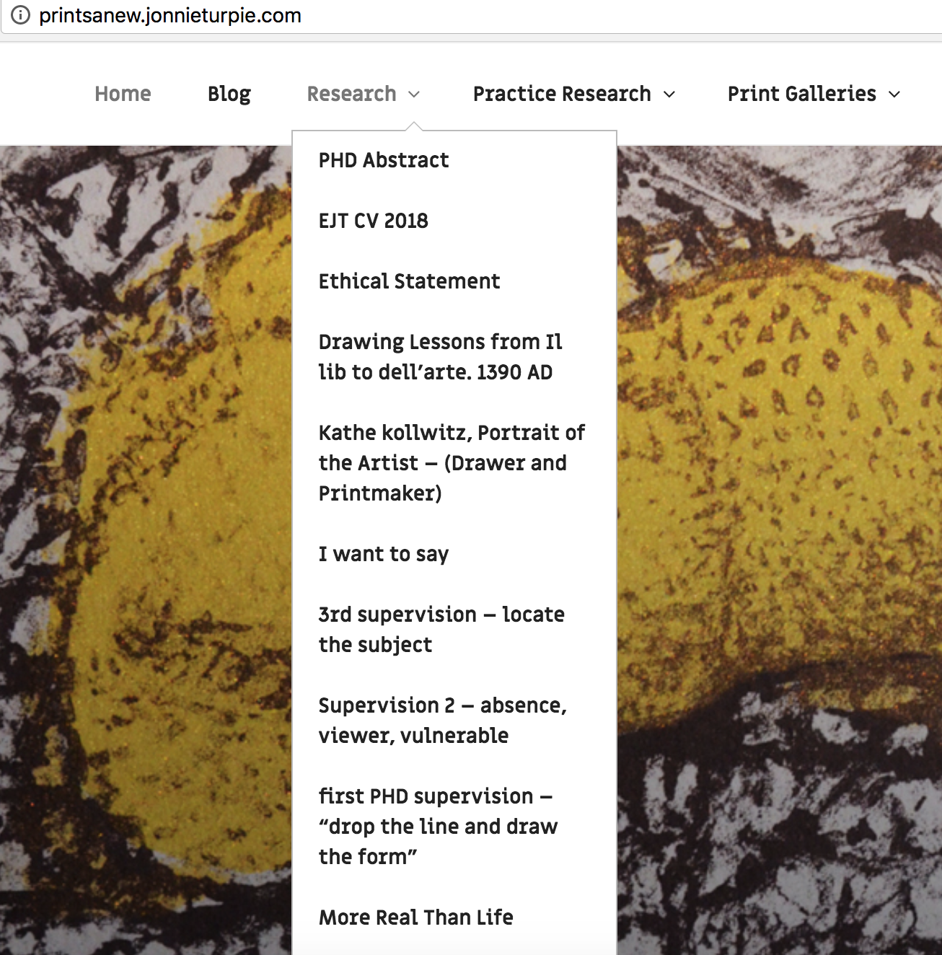
I have developed a dedicated PhD research website to document and track my research development. The site is open to public for general written and practice outputs in the form of artworks. The dedicated PhD Research work is split into two tabs: ‘Research’ and ‘Practice Research’ and are password protected. As well as being an online document repository this is also method of tracking my research development. It also enables sharing of my ongoing findings, thoughts, writing and practice research easily with supervisors.

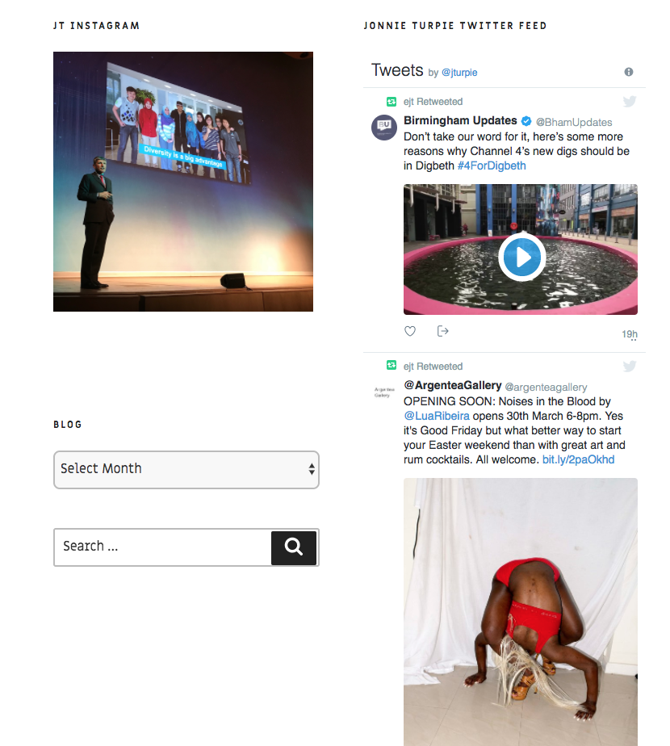
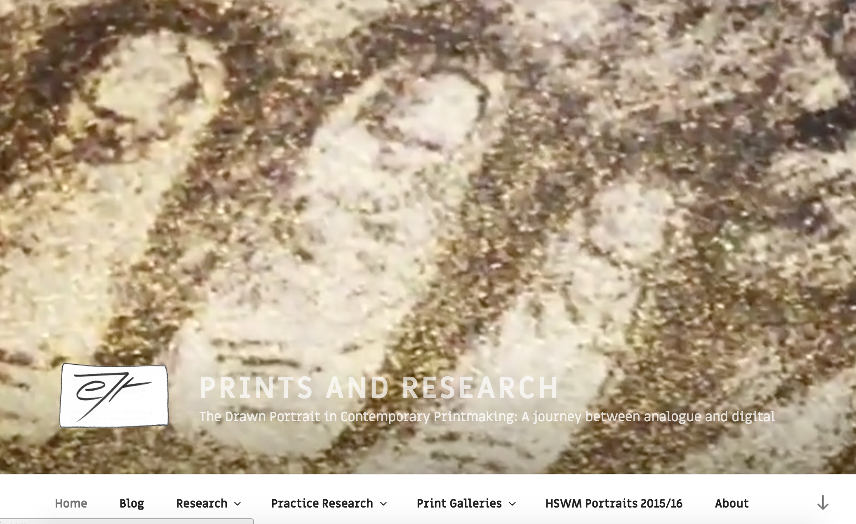

My instagram and twitter channels are connected to the site and enable interaction with users in the field e.g. when attending the PGR Festival. I use the hashtag #PGR_studio in my tweets from cultural and creative industries events.

Practice research
My question is three fold and on every practice artwork exploration I balance all three with their subject specific methodologies. I try, test and assess practice techniques including new digital photography, drawing and print techniques. My research is defining my practice in the context of established drawing and print techniques, and where appropriate describe and name new techniques that I develop. eg ‘mezzoscreen’ describes an amalgam of mezzotint and screen printing that I am developing through investigation into creating backgrounds on mark resist film to draw and scratch into. This research, associated methods and skills development are captured and documented in the Practice Research section of the site in text, images and video. It provides extensive evidence of practice research are here: http://printsanew.jonnieturpie.com

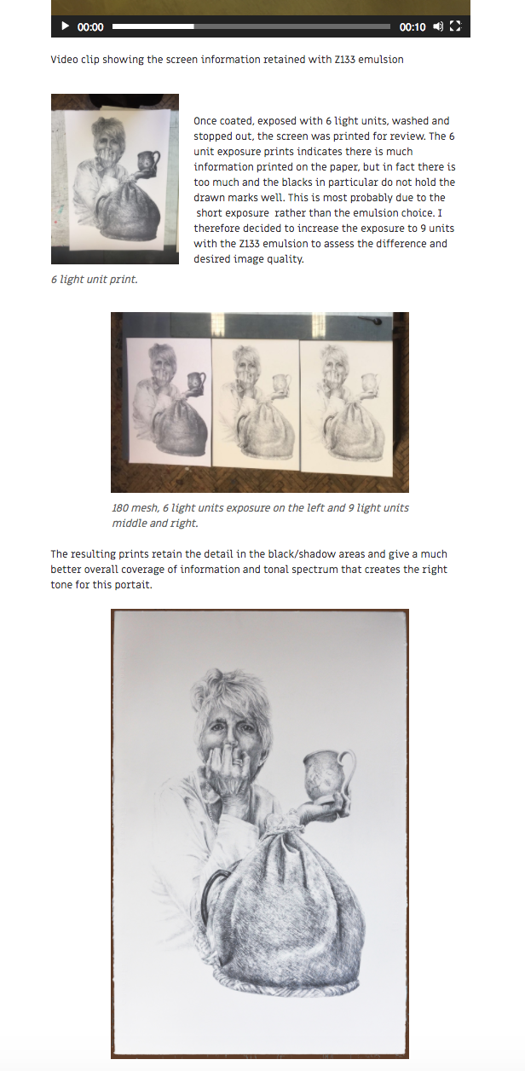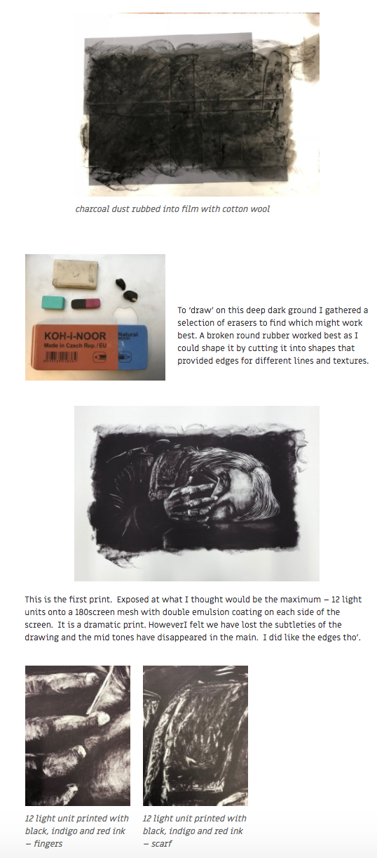

The most recent documentation is : http://printsanew.jonnieturpie.com/rembrandt-huis-printmaking-explorations

Additional practice not directly related to my Research Question, but is beneficial to my extended opportunities include curation, digital drawing and drawing from life.

Curation : I am working with fellow researchers, Artists and Coventry University to curate and project manage a contemporary drawing exhibition and book launch in the International Project Space in the School of Art.

Digital drawing: I am not treating this as a formal part of my practice research, however I regularly draw portraits using this modern medium. These portraits fall into two categories: friends and colleagues I want to celebrate and art gallery viewers.

The first could be termed personal work, which has its rewards in the responses by the subjects which may develop into formal research. The second is a sketchbook for development of drawing, approaches to subject selection and documentation of arts appreciation. It is a space of constant software application development, which is of interest and could become an element for formal research enquiry.

Life Drawing: As a personal challenge to my drawing skills that are framed in my practice research study I have also carried out a series of Life drawing classes to develop my ‘drawing from life’ skills, as opposed to drawing from photography. This is extending my understanding of the range of contemporary drawing. It also provides a learning space for reflection on image making.

Supervision as a method to develop academic and practice research skills and development

The informative and positively challenging supervision input from my Director of Studies, Dr. Catherine Baker has ensured I continue to investigate the premises of my practice alongside extending my established approach to drawing and printmaking. I have learned how to be vulnerable. To reflect and contest my drawing habits, rather than draw and print in secure styles of depiction and representation. I have learned the value of challenging my accepted drawing norms to enable me to select ‘newtome’ mark making methods for particular portraits and extend my drawing abilities. I recognize the value of being open and vulnerable to the research and it the knowledge it affords me. My practice research also addresses the technical and skill base of printmaking whereby I investigate selections of printmaking materials and techniques. I have tested and documented a range of silk screen mesh counts, screen sizes, drawing films, emulsions, inks, paper and exposures to provide a handbook for my research practice.

As a reflective maker I keep track of my development and have extended my supervision session PhD reports by writing reflections on what I have learned, benefited my research and my development as a researcher. My second reflection is here : http://printsanew.jonnieturpie.com/supervision-2-absence-viewer-vulnerable and a summary below, including valuable PGCERT research pointers to ‘doctorateness’ and reflexivity.

Supervision 2 – ABSENCE, VIEWER, VULNERABLE (Turpie.J. 2017)

Dr Baker and I began by reviewing the form drawings that I had made since the first ‘loose the lines, draw the form’ supervision – a hand, a face and a portrait of a young woman concentrating on her homework. My homework was to draw without lines and capture the form of her head. Apart from her (Alex) being my niece I was called to draw her head rather than others in a family gathering because of her concentration, her head and her knotted Taiwaneese hair band, which provided a contrast to her dark hair, in tone, texture as well as emphasising the shape of her head. The drawing began with the cross-hatch drawing of a dark rectangle ground to work from dark to light. This drawing seemed to work reasonably well as it captured her likeness and focus. Dr Baker agreed that this third form drawing had brought a more substantial interpretation, however she asked if I had my drawing ‘kit’. Sadly, I did not have it with me – mistake! – I apologised that I had only one blunt pencil! Another mistake.

Speaking of eyes and isolated body parts, Catherine opened a new sketchbook page, took up an (unforgiving, i.e. un erasable) biro and began drawing early stage heads and suggested I might draw a selected part of a face, rather than automatically assume that a drawing needs to be of the whole head. Perhaps I might look at a subject and leave ‘absences’ that the viewer can fill in rather than be presented with the finished full subject. One of my aspirations might be to ‘encourage the viewer to linger with my artistic outcomes’. Consider the role of the viewer and ways in which, as artists, we can explore mechanisms that encourage audiences to ‘linger with artistic outcomes’.

Last, but not least Dr Baker dropped in a surprising drawing consideration; be vulnerable. I have slowly understood what she meant – be open to risks, new drawing techniques and ways one is seeing and reading the subject and the light that is describing it. Make yourself vulnerable during drawing. Do not always stick to what you ‘know’, let oneself be taken by the subject and your interpretation through the actuality of your drawing of it. This, like so much of what I am experiencing in this early phase of my research is ‘newtome’. It is challenging my drawing capabilities, and it has to be said my psychological understanding of what is at the basis of my image making in the journey(s) between digital and analogue contemporary portraiture.

This notion of vulnerability in practice and reflexivity is enabling me to develop as a practice led PhD researcher.

In this context I am exploring the question of ‘Epistemological Ambiguities’ that has risen in my desire to capture responses to photographic portraiture that do not rely on textual contextualisation but on the photographic practice that will feed into the digital smart phone methodology element of my research. The term ‘Epistemological Ambiguities’ has been pointed to by Dr Jacqueline Taylor through the PGCert programme. Her draft paper: Research-practice-pedagogy: Establishing new topologies of doctoral research in the arts (Taylor.J. 2017.4) includes this definition:

“The epistemological ambiguities of art-based research remain a contentious issue within the academe; often perceived as either elusive or incomprehensible as such research is not easily reconciled with more traditional notions of academic research (Nelson 2013: 4). In the context of the PhD, this is largely because one of the qualities of ‘doctorateness’ is that it is a contribution to knowledge and there is an expectation that such knowledge(s) must be clearly communicable. However, in a similar vain to the performative paradigm Brad Haseman elucidates, that artists often ‘begin something without knowing how it will turn out’ is a core aspect of what drives the creative process (Fisher and Fortnum 2013: 7). Artistic practice instead produces knowledges that happen in a ‘unique material and specific way’ that cannot generically be mapped onto other fields or works of art (Vincs 2007: 11). Rather, it can be perceived to be a form of ‘material thinking’ or ‘praxical knowledge’ that arises through the material handling in practice (Bolt 2007: 29). However, difficulties arise in articulating research where this tacit and slippery knowledge is embodied in process and visual, material and performative art forms, eluding normative signifying structures and communicative language.”

‘This in the context of the PGCert : The PgCert can be seen to function as a threshold space for PhD students at the beginning of their doctoral journey to (un)think what they think they know, raise vital epistemological questions in negotiating practice and theory and question what research itself may mean and become.’

Vulnerability is an attribute I have learned is something a practice based researcher must embrace if one is move forward and develop. Being vulnerable. Being open to ‘unthinking’ what I know. Being open to failure, or more precisely being open to learn from failure.

Ethical Statement.

As surreptitious smart phone photography is core to my research I reviewed the University Ethical Statement questions and realised I could not answer all of issues raised. I took the opportunity to address the areas of doubt and responded with a comprehensive Ethical Statement and submitted to Dr Lawrence Green.

Ethical Statement.
The final statement is included in this submission.

Intended methodological approach
I seek to continue to balance and develop theoretical and practice research methodologies that I have described in this submission and assignment.

Proposed research plan
I will maintain and develop the practice research, expand and refine academic study and writing as per the Gantt forward plan. This plan captures my research intentions over the PhD research period. It covers a responsive and reflective academic and practice research timeline to ensure I am open, but focused. The breadth of my research will have to be regularly reviewed and (re)structured when required. I have come to understand that research is a fluid process that shifts and responds as new discoveries are revealed. I intend to respond to such movement through reflective evaluation in order to drive my research activities into new areas of enquiry. It also captures the outward expression of my research in terms of conference attendance and paper submissions

Gantt Chart Forward Plan. Is Attached.

References :

Thompson.D. 1933. Il lib to dell’arte Cennino D’andrea Cennini. The craftsman’s handbook. translated daniel v Thompson Dover pubs

Turpie.J. October 2017. http://printsanew.jonnieturpie.com/supervision-2-absence-viewer-vulnerable

Taylor. J. 2017: Research-practice-pedagogy: Establishing new topologies of doctoral research in the arts (draft)

